Сontents

Introduction 2

1. Install Wireshark and learn how to use it 5

1.1 Wireshark installer for 64-bit Windows (or 32-bit) 6

1.2 WireShark Install on Mac OS X 9

1.3 Installation of WireShark on Ubuntu 10

1.4 Use of Wireshark 10

2. Find projects on GitHub related to establishing wi-fi connection and run them 16

2.1 A project startup on GitHub 16

2.1.2 Adding of files in a local repository 17

2.1.3 Creation of the version of the project 19

2.1.4 Creation of a repository on Github 21

2.2 The review of projects on github connected to creation of the Wi-fi network ………………………………………………………………………………….22

2.3 Collecting statistical data using wireshark about your own Wi-Fi connections……………………………………………………………………..25

2.3.1 Analysis of a network traffic 27

2.3.2 Wireshark filters 29

2.4 Diagnostics of problems of a network 37

2.5 Collection of statistics about failures 40

3. Creating Your Own Custom Wireshark Dissector 53

3.1 Configure Wireshark Build Environment (Win32) 53

3.2 Execute the Compiled Wireshark 60

3.2.1 Understanding the AMIN Protocol 60

3.2.2 Package Length Prefix 61

3.3 Examining the AMIN protocol in Wireshark without a custom dissector 62

3.3.1 Writing Your Own Dissector 62

3.3.2 Your Dissector Code 63

3.3.3 Compiling packet-yourprotocol.c 70

3.4 CodeBase and Other Examples: develop Wireshark dissectors using the TSN.1 71

# Introduction

From all methods of a study of computer networks the analysis of a traffic - the most laborious and labor-consuming. Intensive flows of the modern networks generate a lot of unsolved material in which it is not simple to find particles of the useful information. During the existence the stack of TCP/IP acquired numerous applications and additions, the score which goes on hundreds and thousands. These are application and official protocols, authentication protocols, tunneling, a network access and so on. Except knowledge of elements of network interactions, the researcher of a traffic needs to be guided freely in all this legal diversity and to be able to work with specific software tools - analyzers of a traffic (protocols).

The functionality of the analyzer of a traffic is not only a possibility of use of promiscuos of an operation mode of the network interface card for interception. Similar software shall be able to filter effectively a traffic both at a collection stage, and during a study of separate units of transmission (frames, packets, segments, datagrams, messages). And the more protocols analyzers of a traffic "knows", the better.

The modern analyzers of protocols of a lot of things are able: to read traffic statistics, to draw diagrams of the course of network interactions, to derive data of application protocols, to export results of operation to different formats. Therefore selection of tools for the analysis of a network traffic is a topical issue. In this operation methods of the analysis of a traffic by means of Wireshark program tools are provided.

Wireshark is a powerful network analyzer which can be used for the analysis of the traffic passing through the network interface of the computer. It can be necessary for detection and the solution of problems with a network, debugging of web applications, network programs or the websites.

Wireshark allows to view completely packet contents at all levels, so you will be able to understand better how the network at a low level works.

To conduct researches of network applications and protocols and also to find problems in network functioning, and that is important, to clarify the reasons of these problems.

It is quite obvious that in order that it is the most effective to use traffic analyzers, the general knowledge and understanding of operation of networks and network protocols is necessary at least.

All packets are intercepted in real time and are provided in a format, convenient for reading. The program supports very powerful filtering system, illumination in color, and other features which will help to find the necessary packets.

In this thesis we considered options of use Wireshark for the analysis of a traffic.

Research object: analysis of network protocols.

Object of research: applications of the software of Wireshark for systems analysis of a traffic of the Wi-fi network.

Operation purpose: to carry out the analysis of efficiency of the Wi-fi network.

For achievement of a goal research problems were defined:

1) To study features of the modern analyzers of protocols of a network.

2) To study methods of operation Wireshark.

3) To carry out installation of Wireshark on different platforms (OS).

4) To carry out search and a project startup on github.

5) To make collection of statistical data by means of wireshark about own Wi-Fi.

# 1. Install Wireshark and learn how to use it

Wireshark - the program for monitoring the Internet of a traffic. It intercepts TCP packets which were accepted by the computer or are sent from it. It is possible to view contents of packets, to look for errors and so on. By means of wireshark it is possible to pull out any file from packets and to view it.

Wireshark is rather known tool for capture and the analysis of a network traffic, actually the standard both for education, and for a trablshuting.

Wireshark works with the vast majority of the known protocols, has the clear and logical graphic interface on the basis of GTK+ and the most powerful system of filters. Cross-platform, Solaris, FreeBSD, NetBSD, OpenBSD, Mac OS X, and, naturally, works with Windows in such OS as Linux. Is distributed under the license GNU GPL v2. It is available free of charge on the website wireshark.org.

Advantages:

• cross-platform (versions for Linux, Mac, Unix, Windows);

• the utility is free;

• possesses a wide functionality;

• flexibility of setup;

• possibility of traffic filtering;

• creation of own filters;

• interception of packets in real time.

Here main opportunities of the program:

▪ Capture of packets in real time from wire or any other type of network interfaces and also reading from the file;

▪ Such interfaces of capture are supported: Ethernet, IEEE 802.11, PPP, and local virtual interfaces;

▪ Packets can be sifted in a set of parameters by means of filters;

▪ All known protocols are highlit in the list in different flowers, for example TCP, HTTP, FTP, DNS, ICMP and so on;

▪ Support of capture of a traffic of VoIP of calls;

▪ Decryption of HTTPS of a traffic in the presence of the certificate is supported;

▪ Decryption of WEP, WPA of a traffic of wireless networks in the presence of a key and handshake;

▪ Display of statistics of load of a network;

▪ Viewing of contents of packets for all network layers;

▪ Time display of sending and receiving packets.

It is possible to download the latest version from the official site of the program: <http://www.wireshark.org/>.

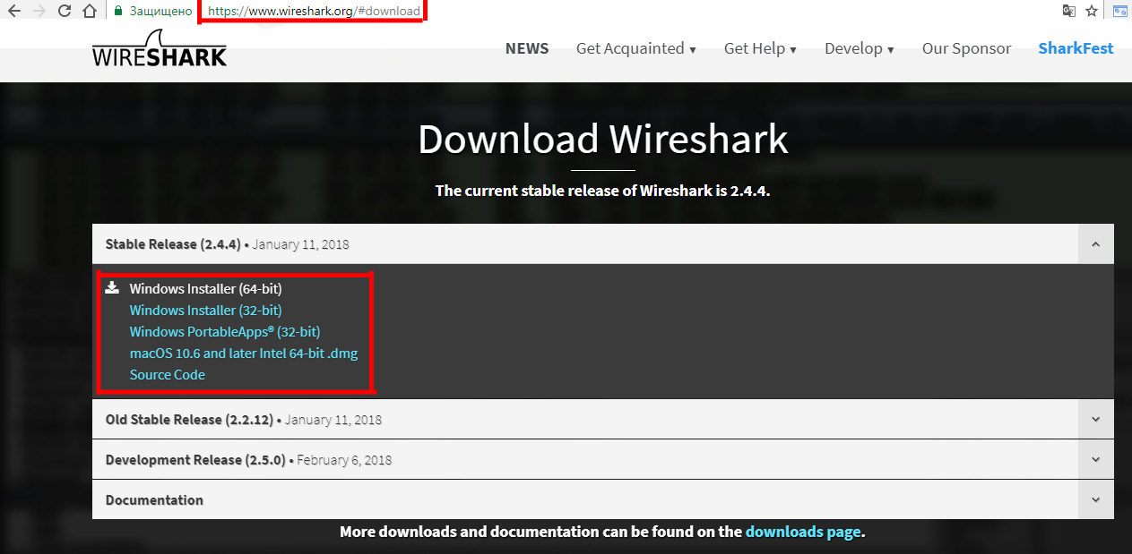

Figure 1.1 – the Order of downloading of the program

## 1.1 Wireshark installer for 64-bit Windows (or 32-bit)

Installation in the Windows system is trivial — next, next, next. Installation of the utility is standard and will not cause any problems even in beginners. In an installer everything is clear.

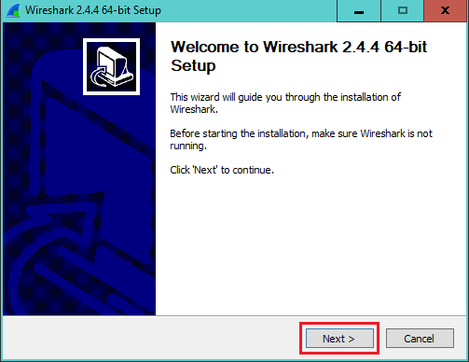

Figure 1.2 - Step 1

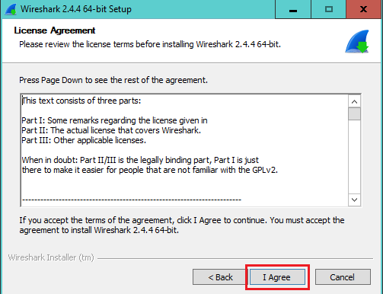

Figure 1.3 - Step 2

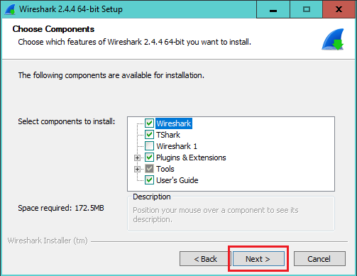

Figure 1.4 - Step 3

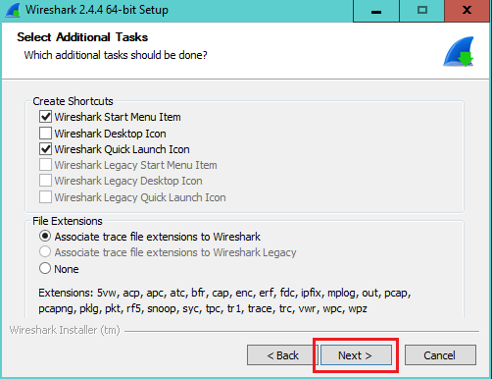

Figure 1.5 – Step 4

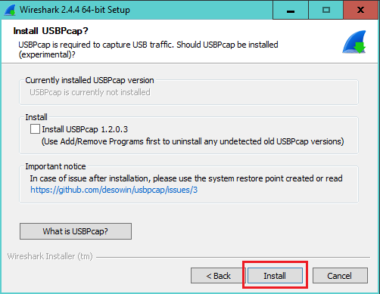

Figure 1.6 - Step 7

## 1.2 WireShark Install on Mac OS X

1. Install XQuartz

Get the installer from here: [http://www.xquartz.org](http://www.xquartz.org/)

2. Install WireShark

3. Do command on the Terminal

Type following command on the Terminal and execute it.

% /Applications/Wireshark.app/Contents/MacOS/Wireshark

Then you would see below answer:

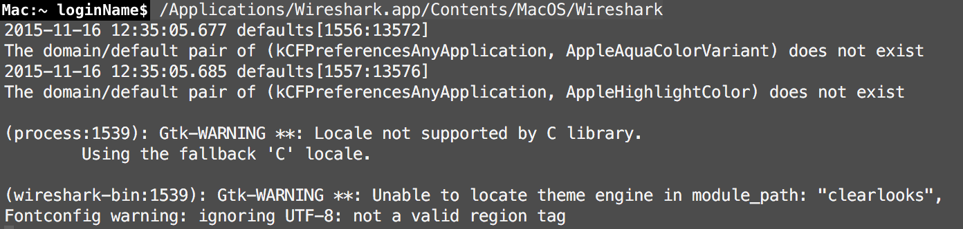

Keep wait for start upWireShark. It will take a few seconds.

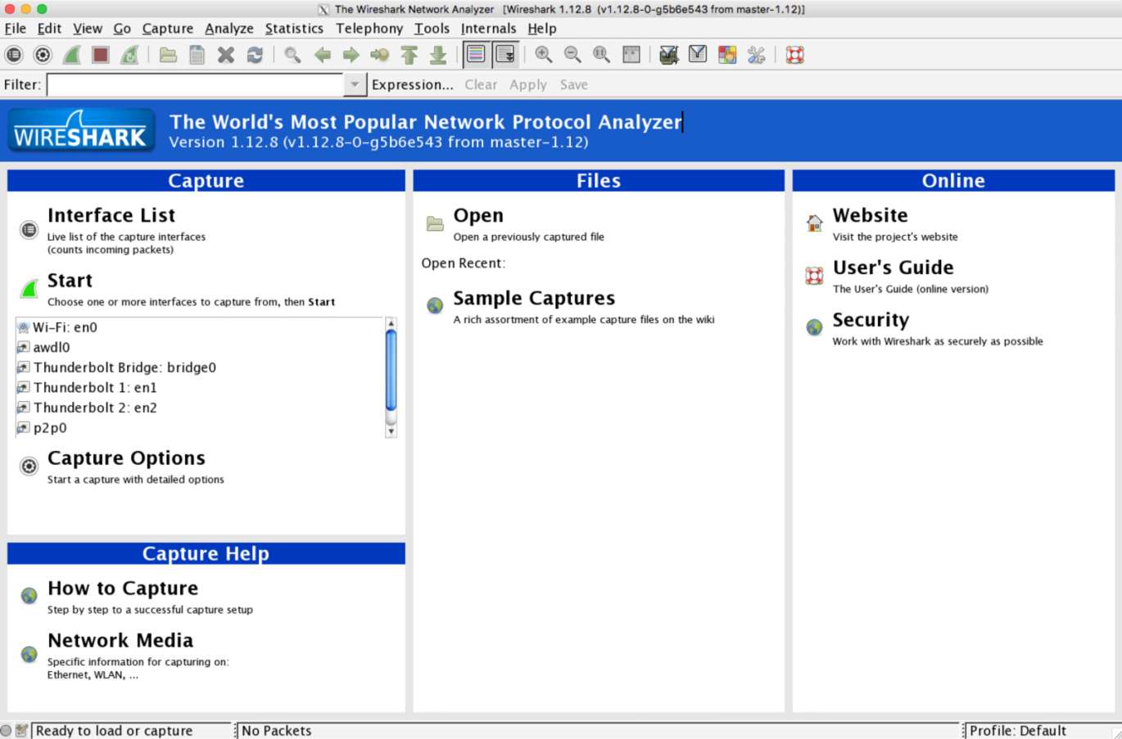

Figure 1.7 – the program Interface

## 1.3 Installation of WireShark on Ubuntu

To Linux WireShark it is available in the form of a packet with the source code which can be downloaded at the following link: https://1.na.dl.wireshark.org/src/wireshark-2.2.5.tar.bz2

It is one many more convenient to set already ready packet.

For this purpose it is enough to execute only 2 steps:

* sudo add-apt-repository ppa:wireshark-dev/stable
* apt-get update
* apt-get install wireshark

## 1.4 Use of Wireshark

After start you will see the main window of the program.

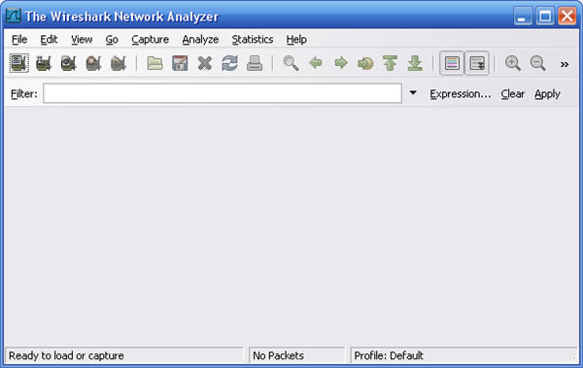

Figure 1.8 – the program Interface

Come into the menu Captur> Options or click Ctrl+K for further setup of parameters of the program.

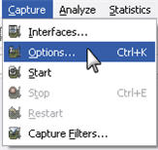

Figure 1.9 – Setup of options

You will see the Capture Options window.

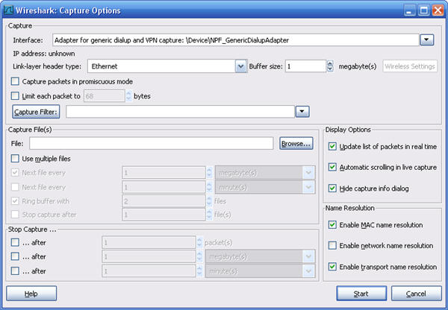

Figure 1.10 – the Section "Setup of Options"

In the field of Interface select from the section Capture from the dropdown list the adapter via which there will be a capture of packets.

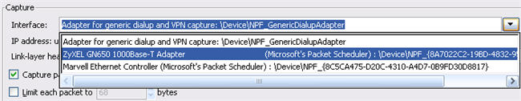

Then press the button to start capture of packets. 

Connect your computer to LAN port of your device. Wait your computer so far will receive the IP address from the device (if the DHCP server is switched on), or set on the computer manually the IP address from the same subnet, as LAN a device IP address.

In the Wireshark program you will see all locked packets which are present at LAN port of the device.

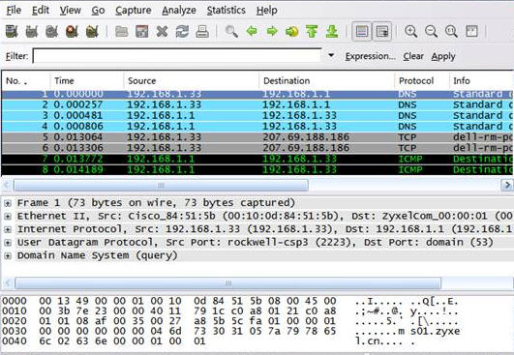

Figure 1.12 – Viewing of locked packets

Attention! You make capture of network packets so that it was possible to see information on a traffic in case of origin of a problem.

For completion of capture of packets press the Wireshark program toolbar button.

Come into the menu File&gt; Save As … for saving locked data in the file.

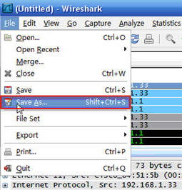

Figure 1.13 – Saving locked data

Select location, enter file name and press the Save button for saving packets.

For convenience of search/viewing of information on the necessary packets in the Wireshark program it is possible to filter locked packets on the IP address or port number.

We will give examples: If you want to make filtering locked packets on the IP address of assignment 88.255.67.145, in the field of Filter specify the rule of the ip.dst filter == 88.255.67.145

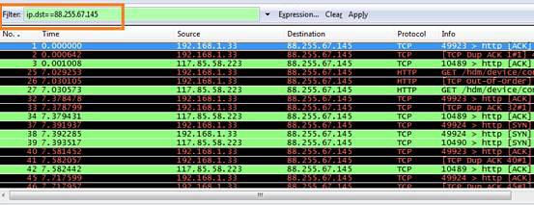

Figure 1.14 – Filtering locked packets

If you want to make filtering locked packets on a certain port TCP (for example, on the 80th port), in the field of Filter specify the rule of the tcp.port filter == 80

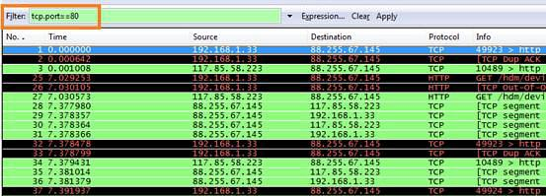

Figure 1.15 – Filtering locked packets to a certain port TCP

If you want to make filtering locked packets on two certain IP addresses (for example, on IP addresses 88.255.67.145 and 117.85.53.223), in the field of Filter specify the rule of the ip.addr filter == 88.255.67.145 and ip.addr == 117.85.53.223

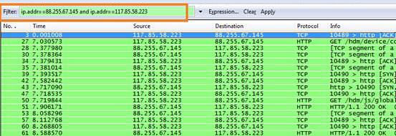

Figure 1.16 – Filtering locked packets on IP addresses

# 2. Find projects on GitHub related to establishing wi-fi connection and run them

The website github.com is positioned as a web service of a hosting of projects with use of the control system of versions of gitand also as a social network for developers. Users can create unlimited number of repositories, for each of which wiki, the issue tracking-á system is provided, there is an opportunity to carry out code review and many other things.

GitHub at the moment is the most popular service such, having overtaken Sourceforge and Google Code.

For open-souce of projects use of the website is free. If necessary to have private repositories, there is an opportunity to transfer to a paid tariff plan.

The Git system appeared as a control source texts in the Linux operating system and I won a great number of admirers in the environment of Open Source.

## 2.1 A project startup on GitHub

The Github service provides a hosting (storage) of source texts both on paid, and on a free basis. It is one of the largest systems which users love Open Source. The main difference of the paid version is a possibility of creation of private repositories (storages) of source texts and if you have nothing to hide, then you can quietly use the free version.

**2.1.1 Creation of a local repository**

We will assume that your project is in folder/home/user/project. Before saving the source code, it is possible to look whether there are no temporal files in the folder with the project and whenever possible to delete them.

For viewing of the folder it is convenient to use the tree command which will show not only contents of each folder, but also a tree structure of directories.

Often temporal files contain specific suffixes on which it is easy to find them and in a consequence to delete. For search of such files it is possible to use the find command. As an example we will look how to find all files which are generated by the compiler Python and have extension of .pyc.

We pass into the folder with project/home/user/project:

cd /home/user/project

Also we show the file list with extension of .pyc:

find . -name *.pyc

This command will output the list of all files with extension of .pyc in the current directory and in its subdirectories. For deleting the found files, it is enough to add a key - delete to this command:

find. - name *.pyc - delete

It is very much recommended not to hurry and directly not to add this key. The first time to cause a command for viewing of files and having only convinced that nothing was included in the list of the useful to add a deleting key.

We will create a local repository in the folder with the project:

gitinit

After execution of this command the new folder with the name .git will appear. In it there will be several files and поддиректориев. At the moment the version management system does not see our files yet.

### 2.1.2 Adding of files in a local repository

For adding of files the command is used:

git add readme

After command execution, the readme file will be added to management system of versions (of course if it already was that it in the project). When adding the file the hash value which looks approximately so is generated:

9f2422325cef705b7682418d05a538d891bad5c8

The added files are stored in the .git/objects/xx/yyyyyyyy folder, at the same time the first 2 digits of a hash ipolzutsya for specifying of a directory, and remaining a hash the value is file name. Our added file will be is here:

.git/objects/9f/2422325cef705b7682418d05a538d891bad5c8

That it is easy to see by means of a command:

ls .git/objects

The file is archive which is easy for unpacking and displaying, having specified complete value of a hash.

git cat-file - p 9f2422325cef705b7682418d05a538d891bad5c8

To add all files from the current directory enter:

git add.

If it is necessary to add files from the current directory and from all поддиректориев, then use:

git add - all

In order that temporal files did not get to system, it is possible to enter them in the .gitignore file which needs to be created independently and to place in the root directory of the project (at the same level, as .gitdirektoriya).

For example, if in to add the following line of *.pyc to the .gitignore file, then all files with extension of .pyc will not be added to a repository.

After adding of files, all changes are in so-called staging (or cached) area. This some temporal storage which is used for accumulation of changes and from which versions of projects (commit) are created actually.

For viewing of a current status it is possible to use a command:

git status

After command execution we will see that in stage area there is our file:

new file: readme

If you continue to make changes to the readme file, then after git status instruction fetch you will see two versions of the file.

new file: readme

modified: readme

To add new changes it is enough to repeat a command. The git add command not only adds new files, but also all changes of files which were added earlier.

git add readme

It is possible to cancel adding of the readme file in staging area by means of a command:

gitrm - cached readme

After command execution, the readme file will be marked as not changed by system.

### 2.1.3 Creation of the version of the project

After we added the necessary files to staging area we can create the version of the project. By means of a command:

git commit - m "comment"

Each new version is followed by the comment.

After the kommit, we will be able to find two new objects in repository .git.

.git/objects/9f/2422325cef705b7682418d05a538d891bad5c8

.git/objects/65/7ab4c07bd3914c7d66e4cb48fe57f5c3aa7026

.git/objects/da/c6721c3b75fcb3c9d87b18ba4cef2e15e0a3d3

We will look that inside:

git cat-file - t 657ab4c07bd3914c7d66e4cb48fe57f5c3aa7026

The key - t shows an object type. As a result we see:

commit

For the second object:

git cat-file - t dac6721c3b75fcb3c9d87b18ba4cef2e15e0a3d3

Result:

tree

For the very first file:

git cat-file - t 9f2422325cef705b7682418d05a538d891bad5c8

We see: blob.

If we study further contents of these files, then we will find a tree structure. From each comment it is possible to follow the links according to all changed files. It is not really necessary for practical application, but perhaps it will be so easier to understand what happens by operation to the Git system.

The very first version cannot be cancelled. It can only be corrected. If you want to add change to the latest version, then after execution of the command of commit, you add necessary changes and you cause:

git commit - m "comment" - amend

Or so:

git commit - amend - no-edit

The key - no-edit is necessary not to enter again the comment.

It is possible to view changes which you made the last kommit:

git show

Or so:

git show - name-only

The key - name-only is necessary to show only names changed files. Without it according to each changed file the list of all changes will be issued.

If you continued to work and changed only those files which were already added to system by the git add command, you can make kommit one command:

git commit - a - m "comment"

For viewing of the list of all comment, use a command:

git log

Or so:

git log - oneline

The key - oneline is necessary to reduce amount of information given out on the screen. With this key everyone kommit is shown in one line. For example:

2b82e80 update

657ab4c first

To view changes on a specific kommit, there is enough in the gitshowdobavit command the hash value of the kommit which can be received by means of the previous command.

git show 657ab4c

For canceling of the last kommit (except very first) it is possible to use the following command:

git reset HEAD ~ 1

To delete all files in the folder which do not belong to the project and are not saved in a repository, it is possible to use a command:

git clean – df

### 2.1.4 Creation of a repository on Github

Till a present situation we worked with a local repository which remained in the folder on the computer. If we want to have a possibility of saving the project on the Internet, we will create a repository on Github. For a start it is necessary to register on the website github.com under the name of myuser (in your case it can be any other name).

After registration we click a button "+" and we enter the name of a repository. We select the Public type (a repository always of Public for the free version) and we click Create.

As a result we created a repository on the website Github. On the screen we will see the instruction how to connect our local repository to again created. A part of commands is already familiar to us.

We add a remote repository (according to the SSH protocol) under the name of origin (instead of origin it is possible to use any other name).

git remote add origin git@github.com:myuser/project.git

We can view result of adding by means of a command:

git remote - v

If everything was correctly made, then we will see:

origingit@github.com:myuser/project.git (fetch)

origingit@github.com:myuser/project.git (push)

To cancel registration of a remote repository enter:

git remote rm origin

It can be necessary if you want to change SSH access to HTTPS. After that it is possible to add it again, for example under the name of github and the HTTPS protocol.

git remote add github https://github.com/myuser/project.git

The following command you will skid all changes which were made in a local repository on Github.

git push - u github master

The key - u is used to establish connection between a remote repository of github and your branch of master. You can transfer all further changes to a remote repository the simplified command.

git push

We considered basic scenarios of operation with the Git and Github systems. Each command given above has much more keys and according to opportunities.

## 2.2 The review of projects on github connected to creation of the Wi-fi network

In the githubsushchestvuyetsystem there are not a lot of projects similar to the Wireshark program. In this paragraph several programs for the analysis and testing of the Wi-fi networks are described.

Wi-Fi Test Suite Introduction Wi-Fi Test Suite is a software platform originally developed by Wi-Fi Alliance, the global non-profit industry association that brings you Wi-Fi®, to support certification program development and device certification. Non-proprietary components are provided under the ISC License and can be accessed at this open source project on GitHub. Wi-Fi Alliance members can access the full software package, including proprietary components, on the Wi-Fi Alliance member site.

UCC and how to get it:

The Unified CAPI Console (UCC) provides the overall control console for the Wi-Fi Test Suite.

UCC runs tests defined by input text files containing CAPI commands(CAPI specification) . The individual CAPI commands within the input files are handled by UCC to perform functions such as DUT configuration, traffic stream definition, and test execution. UCC will direct specific CAPI commands to the appropriate device. This is accomplished via the Control Network.

Wi-FiTestSuite 10.0.0-beta can be downloaded through the open source repository or by members in the most recent Wi-Fi Test Suite package.

Dependencies: Wi-FiTestSuite requires python version 2.7 to be installed.

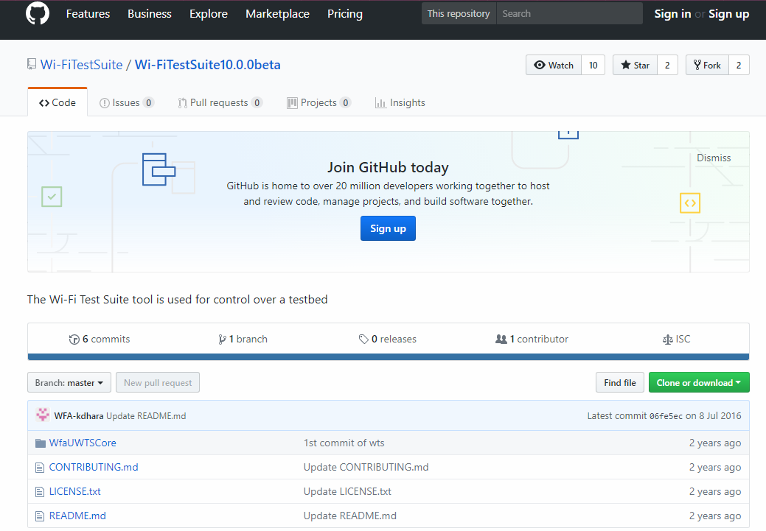

Figure 2.1 - **Wi-Fi Test Suite - 10.0.0-beta**

Wi-Fi Test Suite Introduction Wi-Fi Test Suite is a software platform originally developed by Wi-Fi Alliance, the global non-profit industry association that brings you Wi-Fi®, to support certification program development and device certification. Non-proprietary components are provided under the ISC License and can be accessed at this open source project on GitHub. Wi-Fi Alliance members can access the full software package, including proprietary components, on the Wi-Fi Alliance member site.

Control Agents Control agents are a proxy in which a CAPI control command (CAPI specification) is converted for the device into the device’s native control interface. APs, DUTs, sniffers, and STAs may require control agents. The Linux control agent can be downloaded through the open source repository.

Installation from sources Refer to the Install Guide for instructions on setting up a Linux DUT.

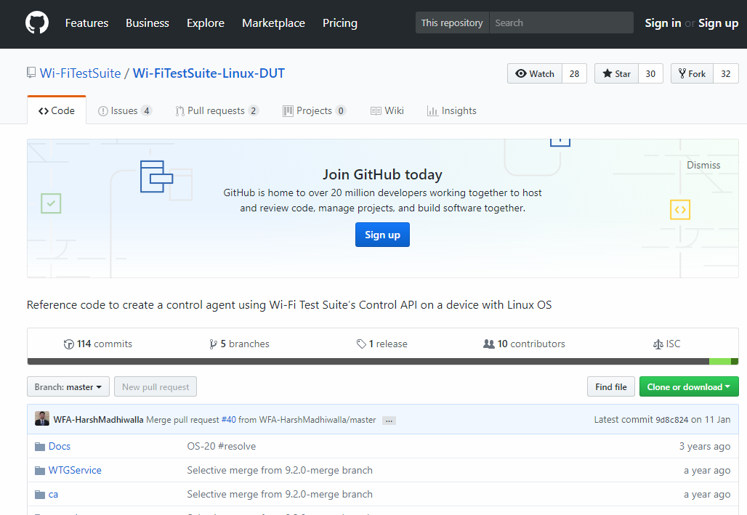

Figure 2.2 - **Wi-Fi Test Suite Linux Control Agent**

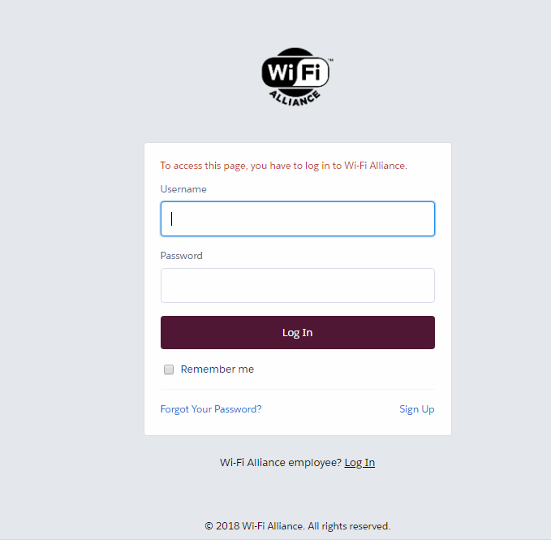

Figure 2.3 - **Wi-Fi Test Suite Linux Control Agent**

## 2.3 Collecting statistical data using wireshark about your own Wi-Fi connections

Wireshark is a powerful network analyzer which can be used for the analysis of the traffic passing through the network interface of your computer. It can be necessary for detection and the solution of problems with a network, debugging of web applications, network programs or the websites.

Wireshark allows to view completely packet contents at all levels, so you will be able to understand better how the network at a low level works.

All packets are intercepted in real time and are provided in a format, convenient for reading. The program supports very powerful filtering system, illumination in color, and other features which will help to find the necessary packets. In this instruction we will consider how to use Wireshark for the analysis of a traffic. Recently developers passed to operation over the second branch of the Wireshark 2.0 program, in it the set of changes and improvings, especially for the interface was made. We will use it to apply.

Before passing to reviewing of methods of the analysis of a traffic it is necessary to consider what possibilities the program supports in more detail with what protocols it can work and what to do. Here main opportunities of the program:

* Capture of packets in real time from wire or any other type of network interfaces and also reading from the file;
* Such interfaces of capture are supported: Ethernet, IEEE 802.11, PPP, and local virtual interfaces;
* Packets can be sifted in a set of parameters by means of filters;
* All known protocols are highlit in the list in different flowers, for example TCP, HTTP, FTP, DNS, ICMP and so on;
* Support of capture of a traffic of VoIP of calls;
* Decryption of HTTPS of a traffic in the presence of the certificate is supported;
* Decryption of WEP, WPA of a traffic of wireless networks in the presence of a key and handshake;
* Display of statistics of load of a network;
* Viewing of contents of packets for all network layers;
* Time display of sending and receiving packets.
* The primary window of the program is partitioned into three parts, the first column contains the list of network interfaces, available to the analysis, the second - options for opening of files, and the third - the help.

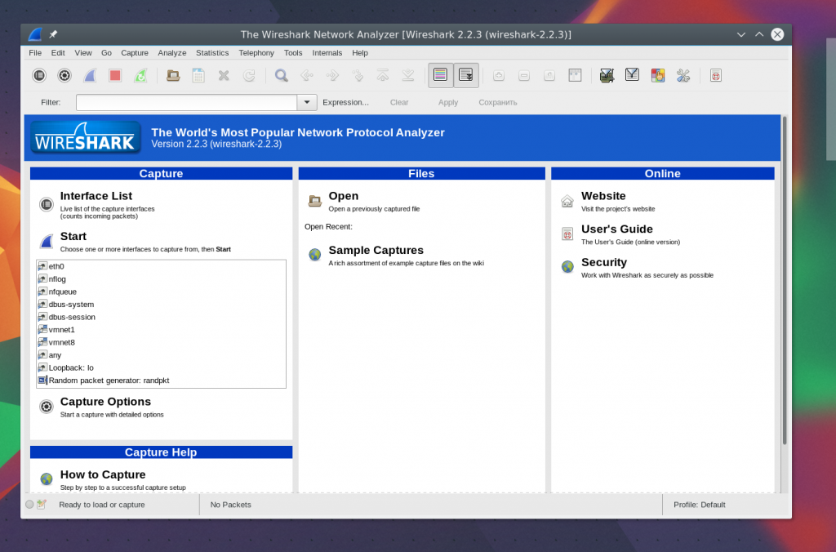

Figure 2.4 – the analyzer Interface

### 2.3.1 Analysis of a network traffic

To start the analysis select the network interface, for example, of eth0 and press the Start button.

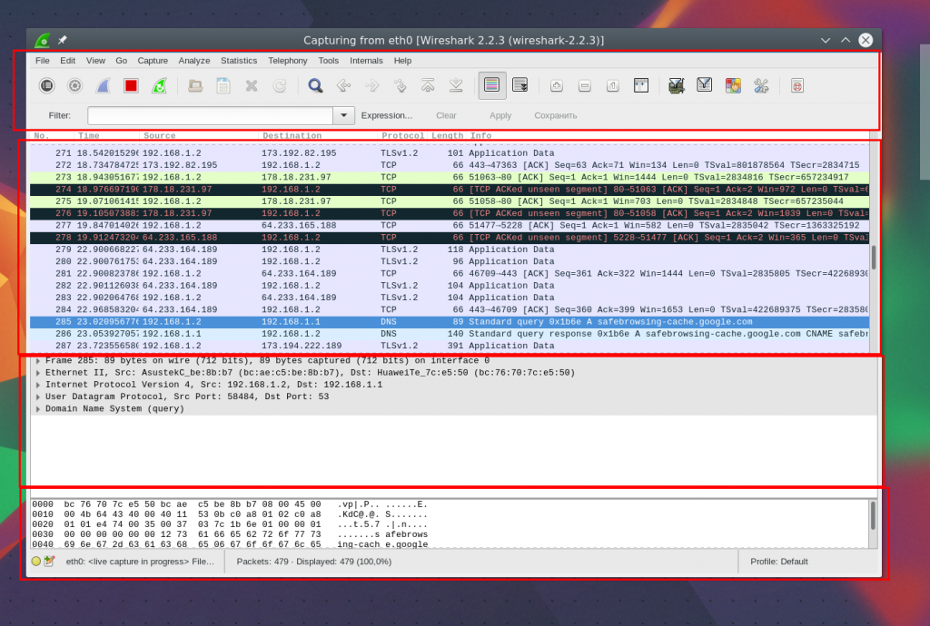

Figure 2.5 – the Beginning of the analysis

After that the following window, already with a flow of packets which pass through the interface will open. This window is partitioned into several parts too:

* The upper part is a menu and a panel with different buttons;
* The list of packets - is displayed further a flow of network packets which you will analyze;
* Packet contents - are located contents of the selected packet slightly below, it is broken on categories depending on the transport layer;
* Real representation - is at the very bottom displayed packet contents in a real look and also in the form of HEX.

It is possible to select any packet to analyze its contents:

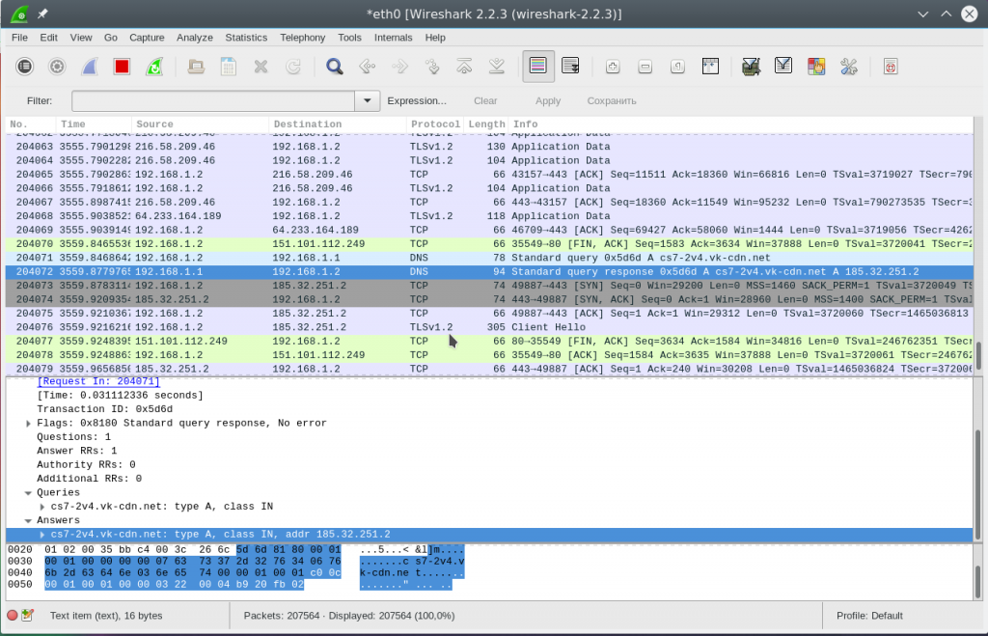

Figure 2.6 – a packet Choice for the analysis

In a figure 2.6 we see a request packet to DNS to receive the website IP address, in the request the domain goes, and in a response packet we receive our question and also the response.

For more convenient viewing it is possible to open a packet in a new window having executed double click of a mouse on record.

### 2.3.2 Wireshark filters

To touch packets manually to find necessary very inconveniently, especially in case of the active flow. Therefore for such task it is better to use filters. For input of filters under the menu there is a special line. You can click Expression to open the designer of filters, but there is a lot of them therefore we will consider the most main:

▪ ip.dst - the target IP address;

▪ ip.src - the IP address of the sender;

▪ ip.addr - ip of the sender or the receiver;

▪ ip.proto - the protocol;

▪ tcp.dstport - the port of destination;

▪ tcp.srcport - port of the sender;

▪ ip.ttl - the filter on ttl, defines network distance;

▪ http.request_uri - the required address of the website.

For specifying of the relation between a field and value in the filter it is possible to use such operators:

▪ == - equally;

▪! = - not equally;

▪ <-it is less;

▪> - it is more;

▪ <= - it is less or equally;

▪> = - it is more or equally;

▪ matches - the regular expression;

▪ contains - contains.

It is possible to apply to combining of several expressions:

▪ && - both expressions shall be correct for a packet;

▪ | | - there can be correct one of expressions.

Now we will consider in more detail on examples several filters and we will try to consider all signs of the relations.

At first we will filter all packets sent on 194.67.215.125 (losst.ru). Collect a line in the field of the filter and click Apply. For convenience wireshark filters can be saved, by means of the Save button:

ip.dst == 194.67.215.125

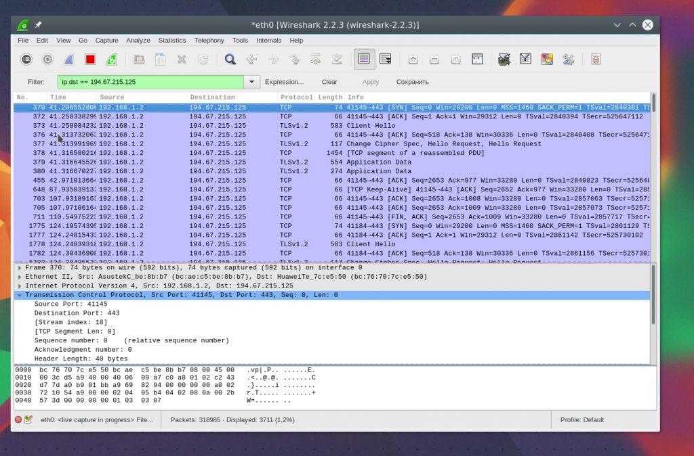

Figure 2.6 – Filtering packets

To receive not only the sent packets but also received in reply from this node we will integrate two conditions:

ip.dst == 194.67.215.125 | | ip.src == 194.67.215.125

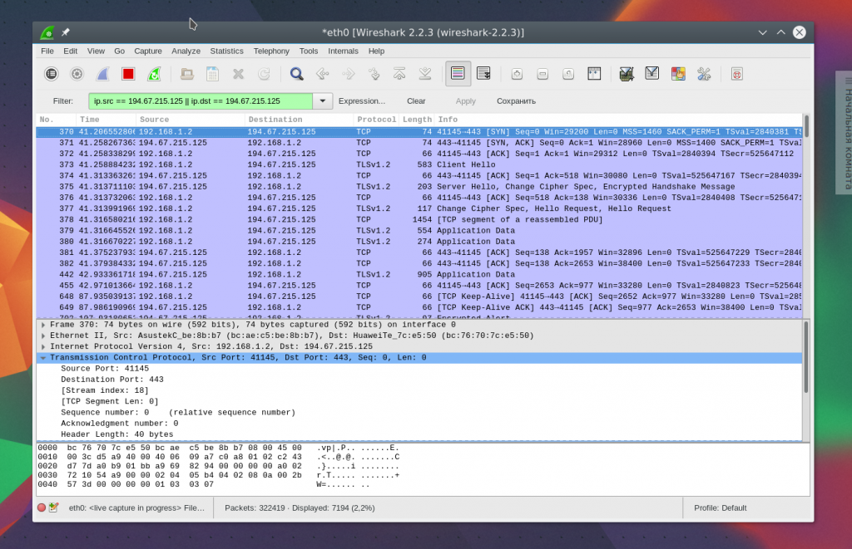

Figure 2.7 – Filtering on a condition

We will select packets with ttl less than 10 further:

ip.ttl<10

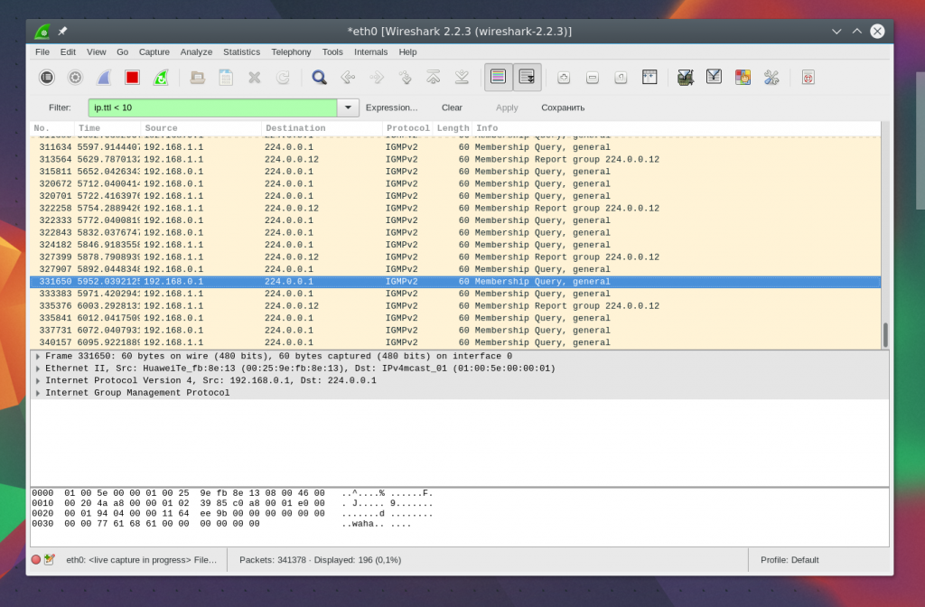

Figure 2.8 - Selection on ip.ttl condition <10

Also we can select the transferred big files:

http.content_length> 5000

Having filtered Content-Type, we can select all pictures which were loaded, we will make the analysis of a traffic of wireshark, packets which contain the word image:

http.content_type contains image

To clean it is necessary to press the Clear button. Happens not always you know all information, necessary for filtering, and just you want to study a network. You can add any field of a packet as a column and look at its contents in the general window for each packet.

For example, we need to remove in the form of the column ttl (lifetime) of a packet. For this purpose open information on a packet, find this field in the section IP. Then open the shortcut menu and select the option Apply As Column:

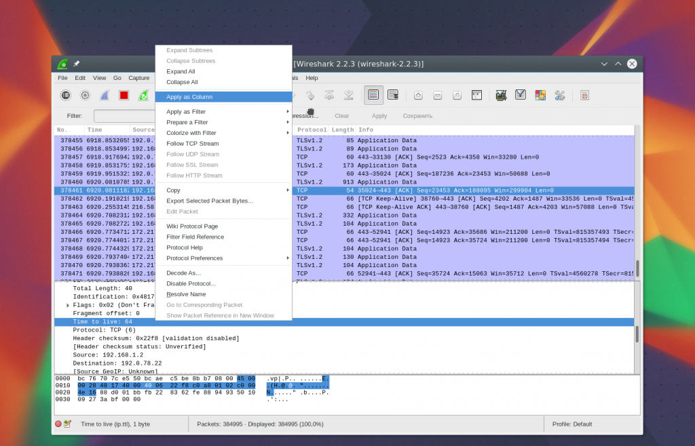

Figure 2.9 - Operation with the option Apply As Column

Further you will see the necessary column after up-dating.

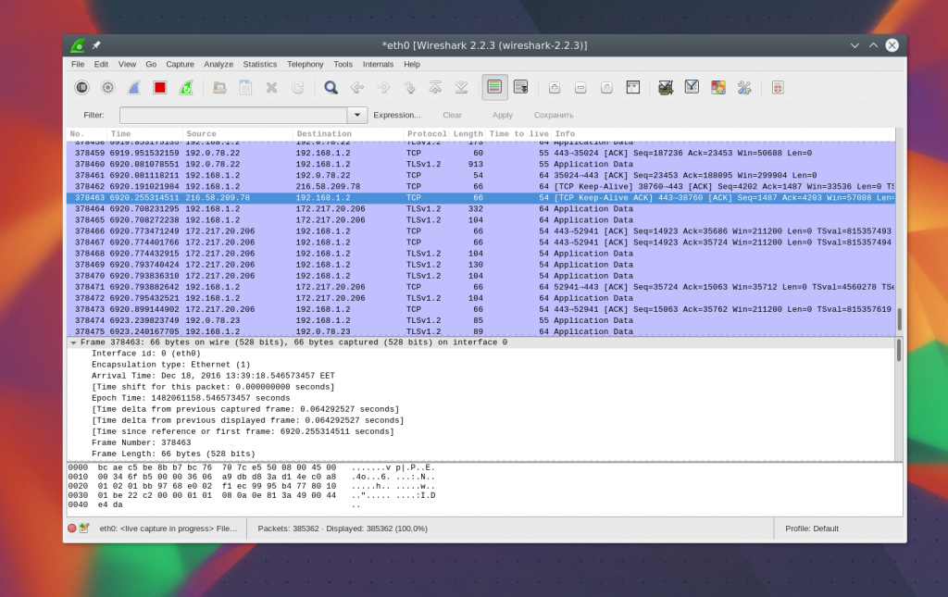

Figure 2.10 – Result of filtering

It is also possible to create the filter on the basis of any necessary field. Select the necessary field and open the shortcut menu, then click Apply as filter or Prepare as filter, then to select Selected to remove only the selected values or Not selected that to move away them.

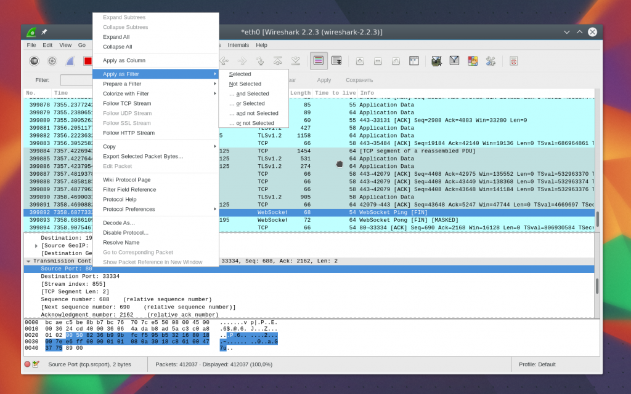

Figure 2.11 – filter Options

The specified field and its value will be applied or in the second case is added in the field of the filter.

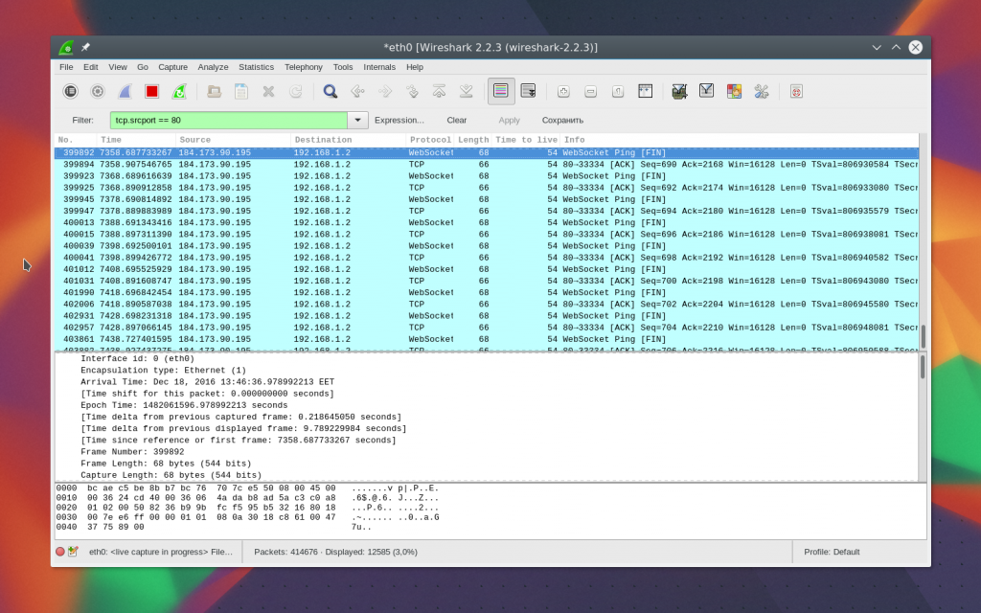

Figure 2.12 – Operation of the filter

In such a way you can add a field of any packet or a column to the filter. There too is this option in the shortcut menu. For filtering protocols you can use also simpler conditions.

For example, we will make the analysis of a traffic of Wireshark for the HTTP and DNS protocols:

http | | dns

We will use the Wireshark tools to tracing of a certain session between the computer of the user and the server. For this purpose we will open the shortcut menu for a packet and we will select Follow TCP stream.

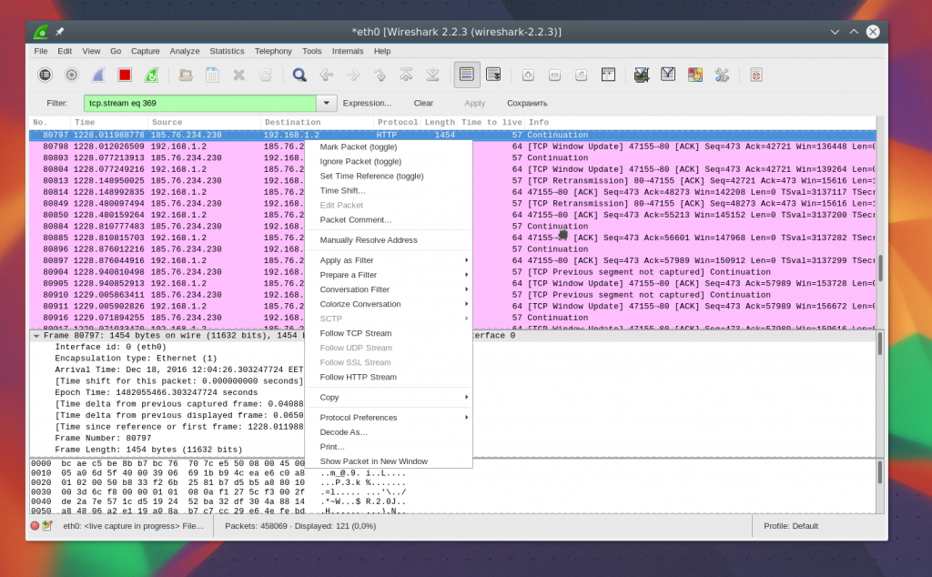

Figure 2.13 - Use of Follow TCP stream

Then the window in which you will find all data transferred between the server and the client will open.

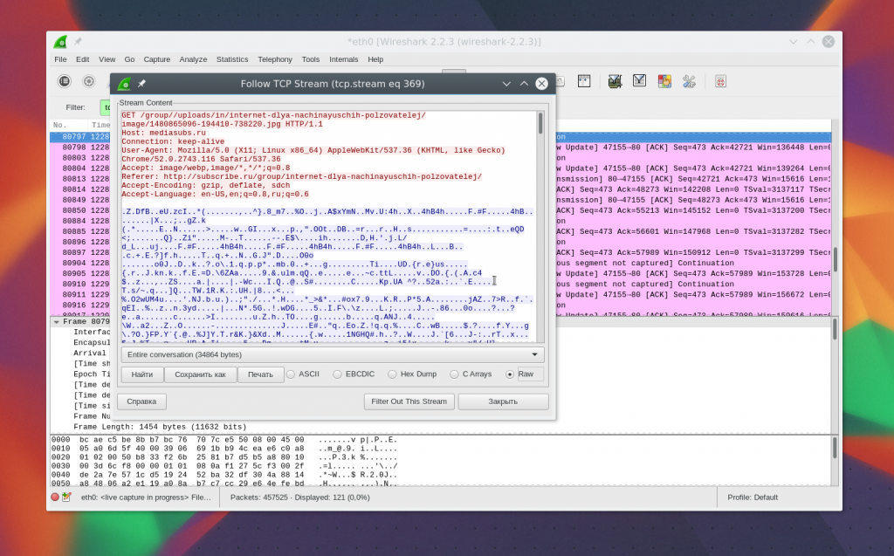

Figure 2.14 - the Data transferred between the server and the client

## 2.4 Diagnostics of problems of a network

For detection of problems on a network in the lower left corner of a window there is a round button, when clicking it the Expet Tools window opens. In it Wireshark collects all error messages and malfunctions on a network.

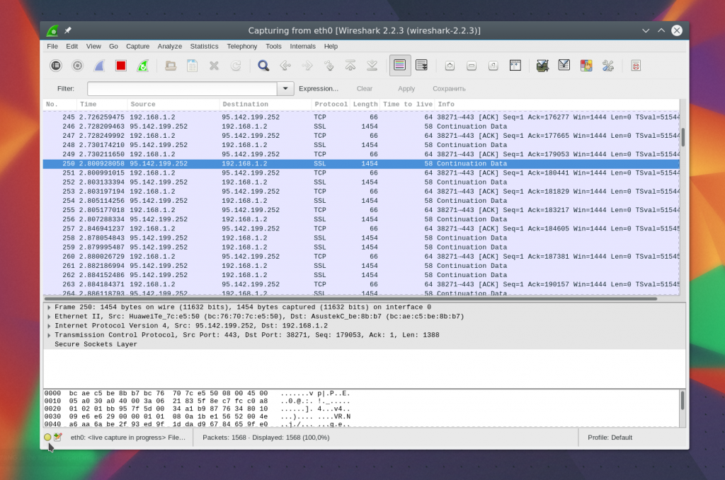

Figure 2.15 - the Expet Tools window

The window is partitioned into such tabs as Errors, Warnings, Notices, Chats. The program is able to filter and find a set of problems with a network and here you can see them very quickly. Here too wireshark filters are supported.

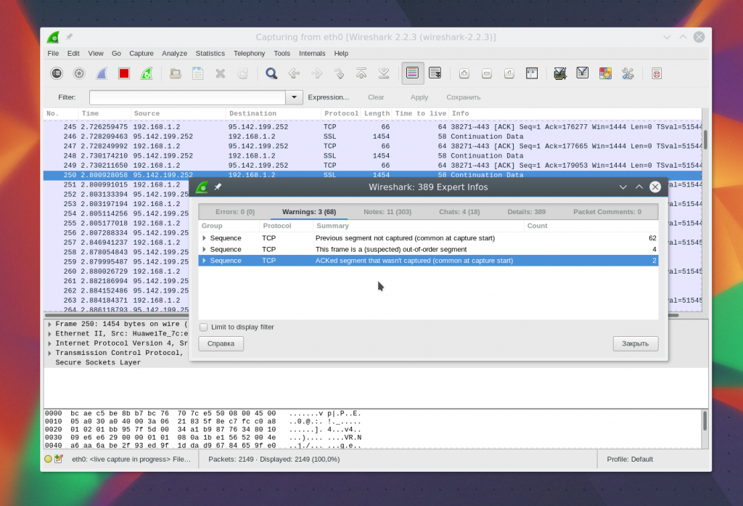

Figure 2.16 – Detection of problems of a network

The program successfully analyzes a traffic. You can very just understand that users downloaded and what files they watched if connection was not ciphered. The program very well copes with extraction of content.

For this purpose at first it is necessary to stop capture of a traffic by means of a red square on a panel. Then open the File menu-> Export Objects-> HTTP.

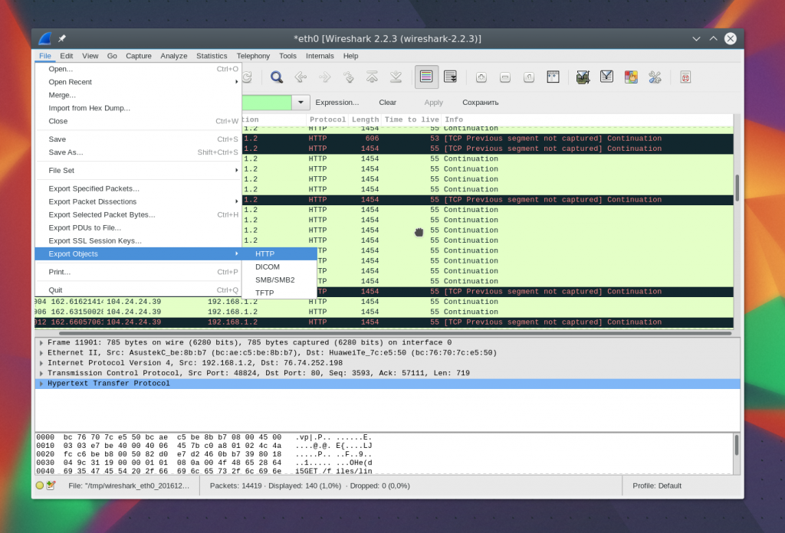

Figure 2.17 – Capture of a traffic

Further, in the opened window you will see all available intercepted objects. It is enough to you to export of them to file system. You can equally save both pictures, and music.

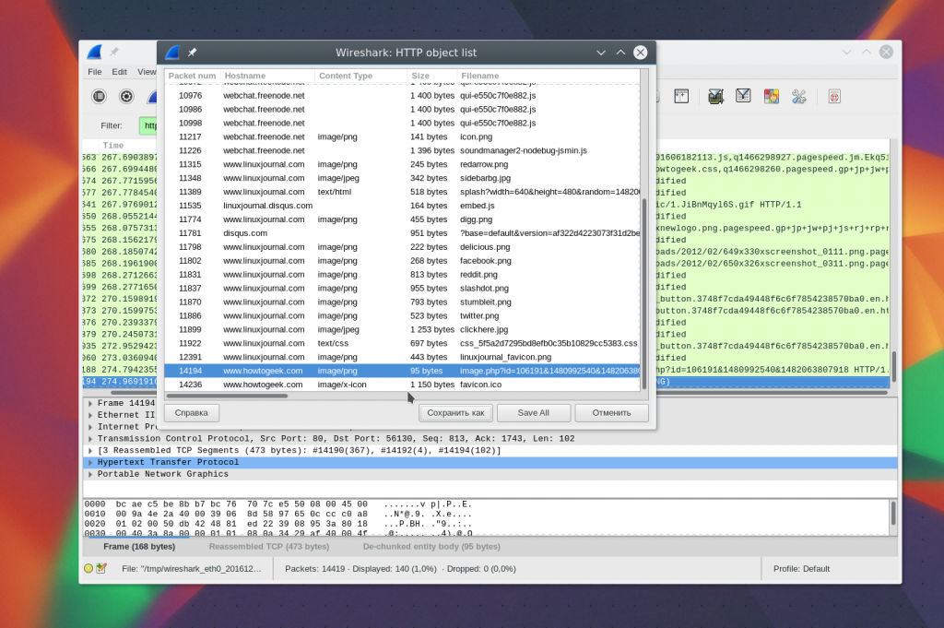

Figure 2.18 - the Review of locked files

Further you can make the analysis of a network traffic of wireshark or directly open the received file other program, for example, a player.

In this chapter we considered how to use Wireshark 2 for the analysis of a network traffic and also the solution of problems with a network. It is very powerful utility which has many functions.

## 2.5 Collection of statistics about failures

The rich set of functionality is provided to the Statistics menu (Statistics) of Wireshark.

At the same time results can be presented not only in the general, but also the graphic form. There is a set from five diagrams of statistics of TCP StreamGraph. They allow to carry out easily and effectively the analysis and diagnostics of TCP connections.

But before beginning to speak about diagrams, for their best understanding we will cover the basics of the theory of TCP.

• TCP (Transmission Control Protocol) — the transport layer protocol which is responsible for the guaranteed delivery of data from one node of a network to another. Over TCP application layer protocols, such as HTTP, FTP, SMTP, TELNET and others work.

• The security of delivery in TCP is reached due to use of mechanisms of confirmations and repetitions.

• After transmission of a portion of data the sender waits for confirmation from the receiver on delivery. If confirmation does not come, resending is executed.

• The data which are subject to sending at the level of TCP are represented by a flow of bytes where each byte sequentially is enumerated. TCP divides a flow into parts — segments — and transfers them to lower (network) level for sending to the receiver. In title of a segment its number (Sequence number, Seq) — number of the first byte of a segment in the general flow is specified.

• The receiver accepts segments and collects from them the initial continuous flow of bytes, sends confirmations.

• In title specifies the confirmation number (Acknowledgment number, Ack) — sequence number of the following segment expected from the sender. The Ack value means that all continuous sequence of bytes from the first to Ack-1 are accepted successfully. According to the specification, confirmation for each segment is not required. One confirmation can go directly to several received segments.

And now we will consider data transfer process in TCP connection through TCP StreamGraph in Wireshark. However, not to describe a graphics just like that, I will make it on a simple and clear example.

I will load the file from a test server on the computer, using the HTTP protocol.

For this purpose I will use the utility of curl, but not a web browser.

curl will help to create some problems which we will see on diagrams.

Problems will arise because loading will be carried directly in the console, but not in the file.

So, I launch Wireshark, I include capture of a traffic.

I load the utility of curl the test file of 10 Mb in size from the v4.speedtest.reliableservers.com server (10MBtest.bin).

I stop capture of a traffic. In the received network dumping of Wireshark I look for HTTP a packet with GET a request of the file 10MBtest.bin and I define number of TCP connection in which it booted. Or we look for on the tcp contains filter "10MBtest.bin".

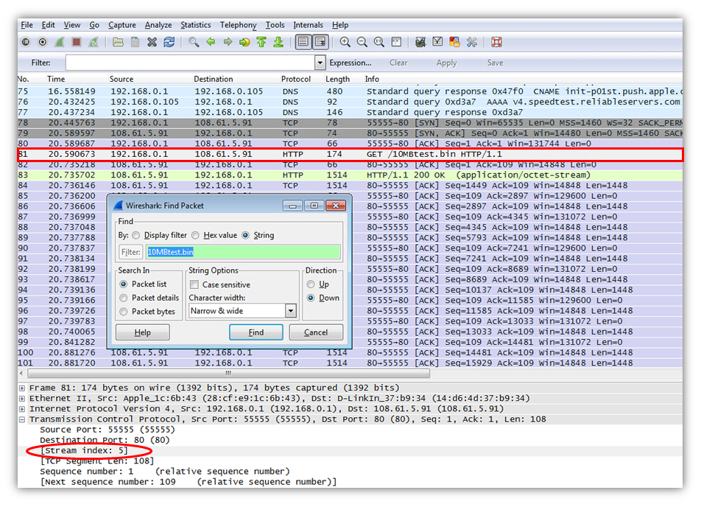

Figure 2.19 – the Stop of capture of a traffic

I filter all traffic according to number of TCP connection in which the test tcp.stream file == 5 booted.

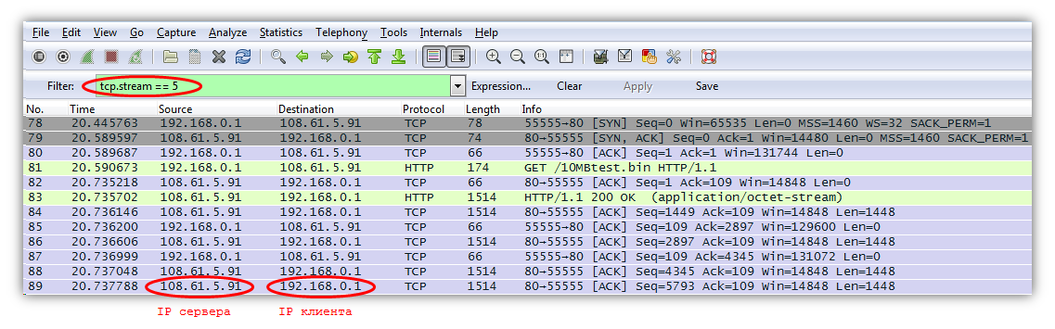

Figure 2.20 – Traffic filtering according to number of TCP connection

Further we watch TCP StreamGraph.

It is important to know that all diagrams are built of TCP StreamGraph on one TCP connection and are directional.

The direction specifies in what direction the analysable data stream from the client to the server or on the contrary moved.

The direction and connection is determined by the packet selected from the Wireshark interface.

In case of the example given above I select any packet from connection in which the test file 10MBtest.bin booted.

The direction was from the server to the client therefore Source of a packet shall correspond to a server IP address.

All diagrams are in Statistics menu Wireshark-> TCP StreamGraph.

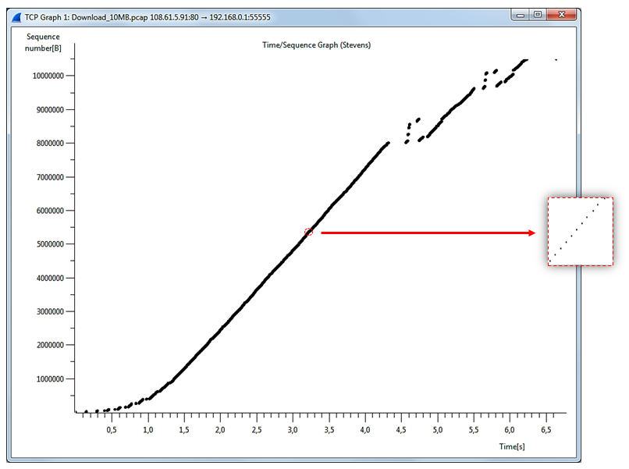

Figure 2.21 - Time-Sequence Graph (Stevens)

Time-Sequence Graph (Stevens) looks as the oblique curve consisting of points.

Coordinates of each point of the diagram are a Sequence number TCP value of a segment (a y axis — Bytes) and time of its capture (a x axis — seconds).

Respectively, as it was told earlier, only the dataful segments of one TCP connection moved in a certain direction from the server to the client (loading, download) or on the contrary are considered (unloading, upload).

According to the theory of Sequence number, it is number of the first byte of data of a segment in the general data stream.

Therefore it is possible to tell that the diagram shows dynamics of loading/unloading of bytes of data in TCP connection on time.

On any section data transmission rate easily is calculated, (Sequence number divided into Time, we receive Byte/sec.).

As a result, on changes of an inclination of sections of a curve it is possible to judge changes of data transmission rate.

In ideal conditions the diagram looks as the diagonal line with big slope angle.

However in practice it not always so.

On anomalies on a curve of the diagram it is possible to reveal time delays in data transfer, losses of segments and their resendings (Retransmission).

On the example of the diagram given below in load time of the file there were two similar problems with a stop of data transfer and loss of segments.

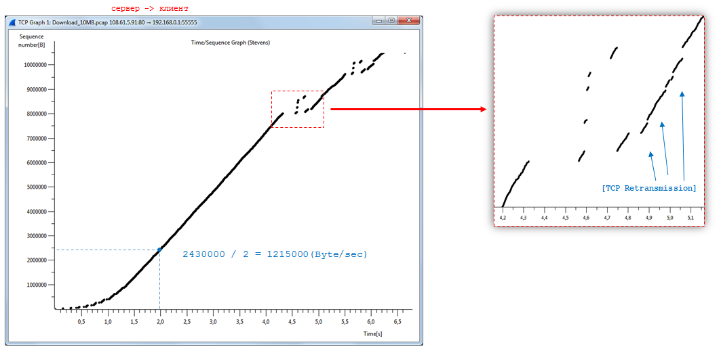

Figure 2.22 – Anomalies of network functioning

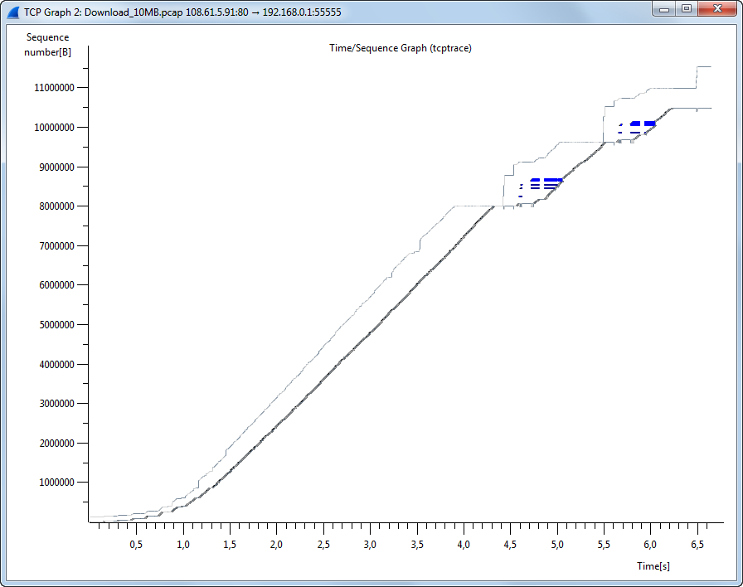

Figure 2.23 - Time-Sequence Graph (tcptrace)

On appearance of Time-Sequence Graph (tcptrace) reminds the previous diagram and it is intended for completer analysis of possible problems. In it Sequence number values of segments of a data stream on a time line are still removed.

However one more attribute of a segment — its size (TCP Segment Len) was added.

Therefore segments are displayed not by points, but vertical segments with cuts on the ends any more as a letter I. The base of a segment is Sequence number, and length — the segment size in bytes.

Also on a graphics information is output from the reverse flow of the confirming segments, by Window (Win), Acknowledgment number (Ack) and SACK. Ack values are displayed by the step curve passing below data segments.

Each step, its peak is a timepoint of arrival of confirmation on a total quantity continuously of the accepted bytes the receiver.

The size of a window of the receiving end Win is similarly displayed. The curve passes above a data stream. The peak of a step is the amount of Ack and Win values of the confirming segment.

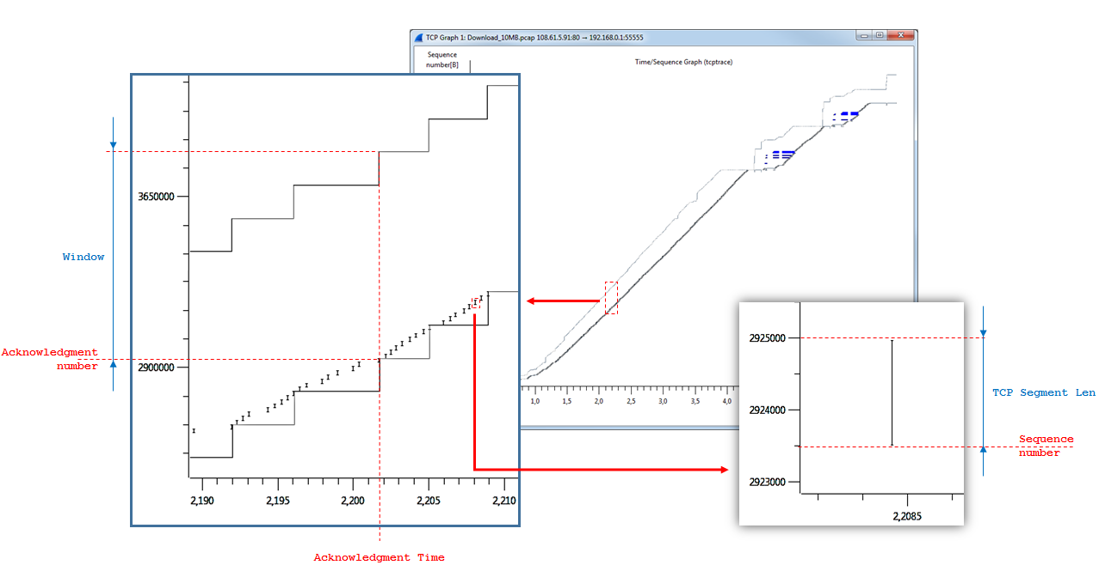

Figure 2.24 – data collection through Time-Sequence Graph

Blue vertical lines visualize SACK units. SACK can be present at confirmation if in a continuous flow of data retrieveds there were gaps.

The blue line is the range of the bytes received after a gap.

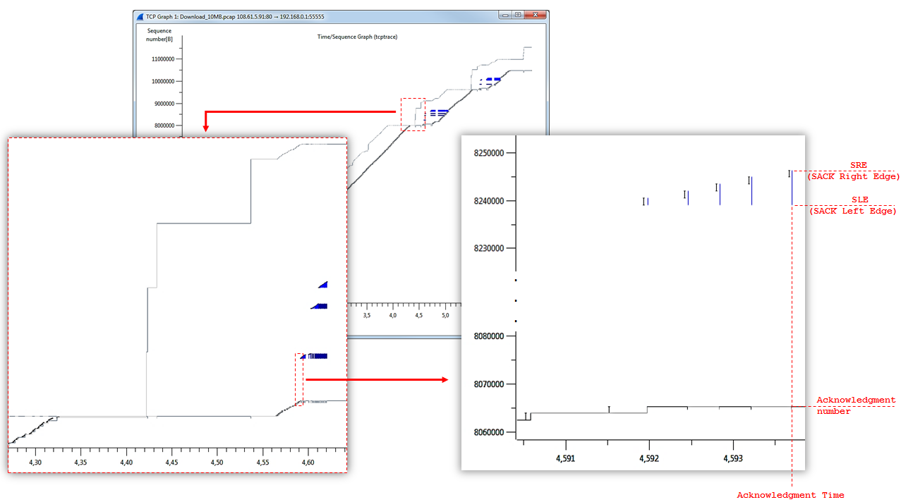

Figure 2.25 – Data after a gap

In a general view the diagram represents "corridor" from two step curves in which dataful segments move. Narrowing of "corridor" speaks about reduction of the size of a window of reception (Win), extension — about reverse.

On the previous diagram two problems with a data transfer stop were found.

Time-Sequence Graph (tcptrace) cleared up the incident reasons.

The size of a window (Win) on the receiving end decreased.

The sender transferred the most admissible quantity of dataful segments not to overflow a window, and stopped.

After the receiver reported about increase in the size of a window (Window Update), data transfer was resumed.

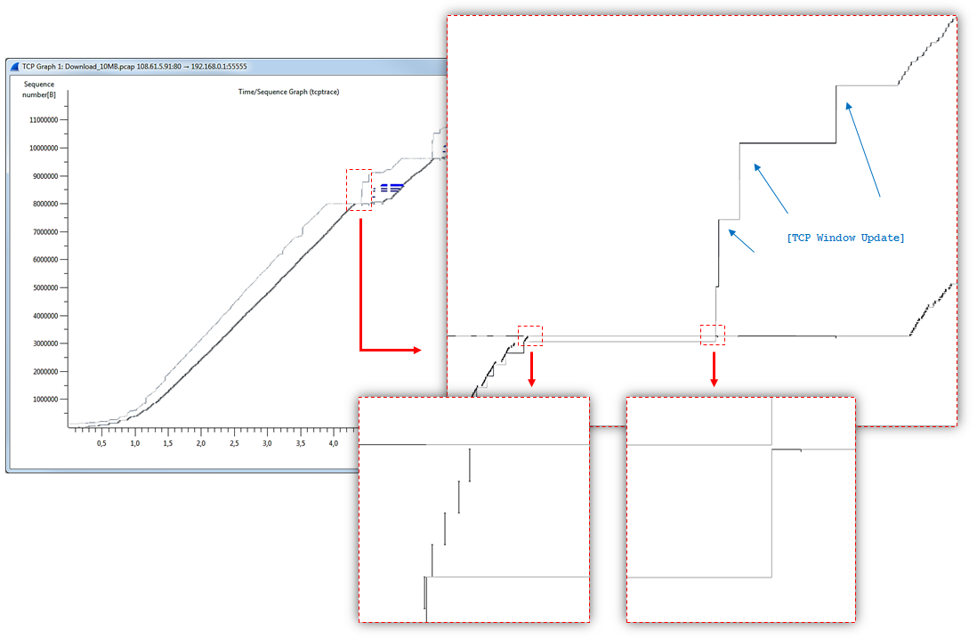

Figure 2.26 – These checks of a traffic

Throughput Graph looks as a set of the points sometimes located very chaotically.

Coordinates of each point are a rated speed of relocation of a segment in a data stream (a y axis — Byte/sec.) and time of its capture (a x axis — seconds).

If to be exact, for smoothing of oscillations on a graphics not real, but average values of speed are fixed.

The averaging function of the sliding average (Moving Average, MA) on 20 values for the previous period is used.

By the Wireshark code, average rate of N-go of a segment is equal to the amount of lengths of all segments from N to N-20, divided into the delta on time between their capture.

As a result, two time delays in data transfer caused by reduction of the size of a window (Win) led to falling of Throughput at problem points of time. In the rest of the time the speed of downloading varied within the range from 1.4 to 3.4 MB.

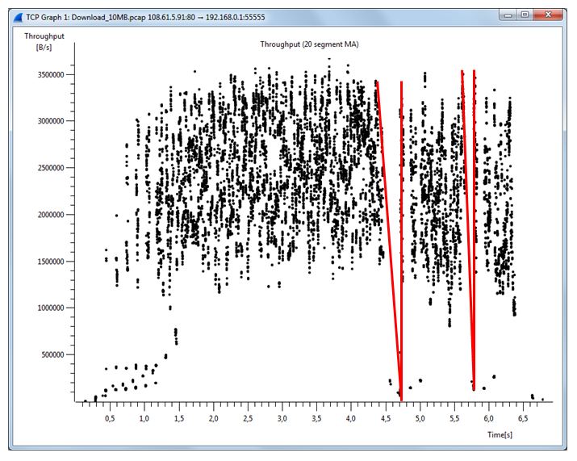

Figure 2.27 – Results of operation of Throughput Graph

Round Trip Time (RTT) is the time which passed between sending a dataful segment and receiving confirmation on its successful delivery.

Round Trip Time Graph shows RTT (a y axis — seconds) on everyone a segment from a data stream.

Its Sequence number appears the identifier of a segment (a x axis — Bytes).

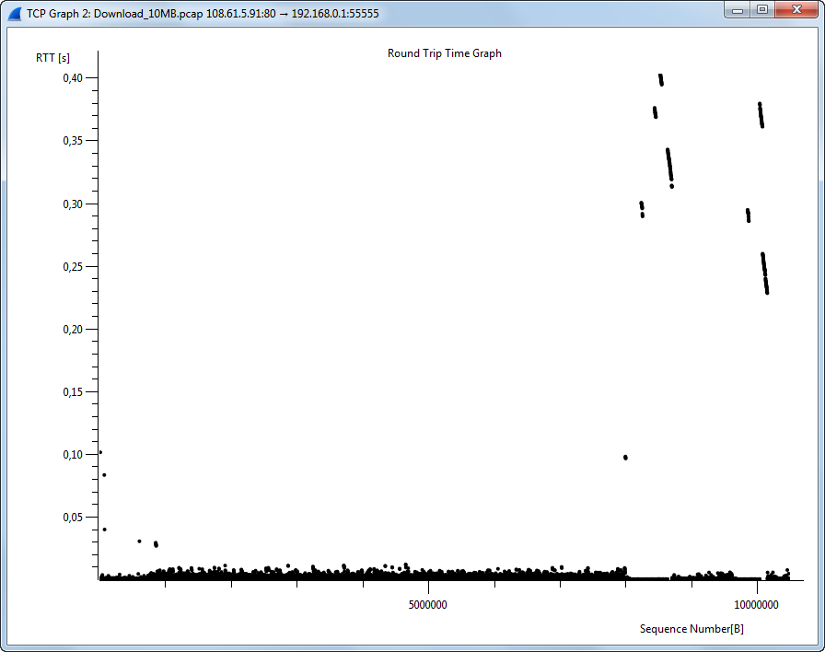

Figure 2.28 – Use of Round Trip Time Graph

Under normal conditions the most part of points concentrates in the lower part of the diagram.

In an example of RTT 0.1 sec. do not exceed almost all the time, except for problem points when RTT jumped up to 0.4 sec.

All diagrams are connected among themselves by a formula Throughput = Window size/RTT.

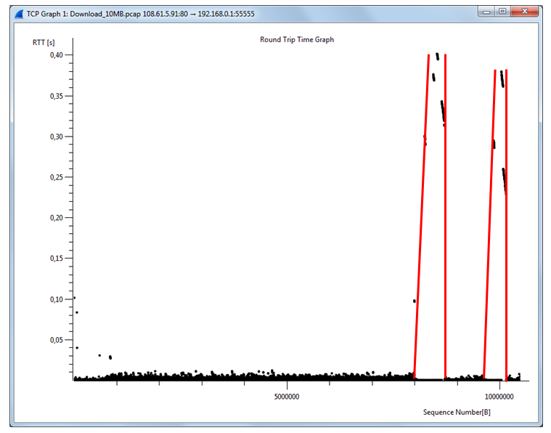

Figure 2.29 – Use of Round Trip Time Graph

Coordinates of each point of Window Scaling Graph are the size of the Windowsize window (a y axis — Bytes) a segment on timepoint of its capture (a x axis — seconds).

In the current diagram a directivity is changed to reverse to a data stream (the client-> the server). In it only the confirming segments are analyzed.

At Window Scaling Graph there is information on two problem cases of abbreviation of the size of a window to the critical sizes.

It completely confirms with indications on Time-Sequence Graph.

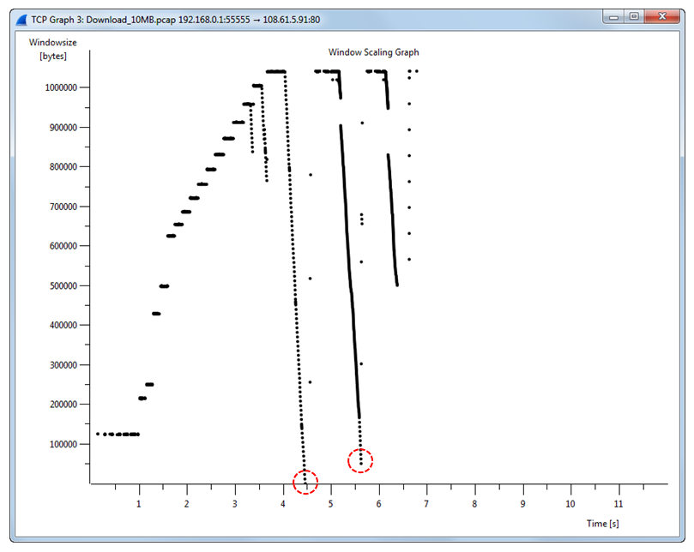

Figure 2.30 – Results of application of Window Scaling Graph

# 3. Creating Your Own Custom Wireshark Dissector

This paragraph describes how to create a Wireshark dissector as well as how to setup the Wireshark build environment.

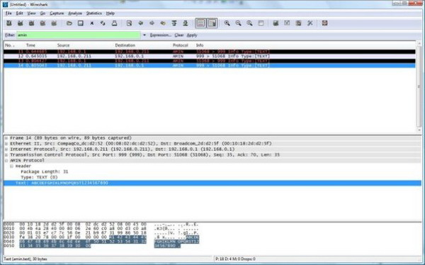

Instructions:

* This part expects the reader to be familiar with structured C, TCP/IP.
* The source code has been designed to compile on Windows.
* A basic knowledge of how to use Wireshark to capture packets.
* A C++ compiler. VS2005/VS2003/VC++6/VS2005EE.

## 3.1 Configure Wireshark Build Environment (Win32)

Step 1. C Compiler

If you do not have VS2005/VS2003 etc., you will need to download and install "Visual C++ 2005 Express Edition".

Step 2. Platform SDK

You must download and install the Platform SDK Server 2003 R2.

Step 3. Install Cygwin

This guide will not go into great details about the Cygwin package. In short, it allows Wireshark to be compiled on Windows and Linux – which is quite a feat. 

At the "Select Packages" page, you will need to select some additional packages which are not installed by default. Navigate to the required Category/Package row, and click on the "Skip" item in the "New" column so it shows a version number for:

* Archive/unzip
* Devel/bison
* Devel/flex
* Interpreters/perl
* Utils/patch
* Web/wget

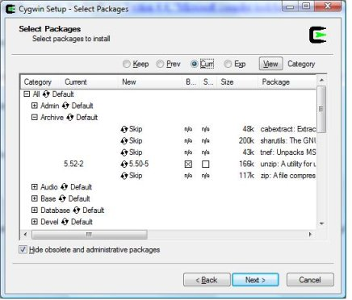

After clicking the Next button several times, the setup will then download and install the selected packages (this may take a while).

Step 4. Install Python

Get the Python 2.4 installer and install Python into the default location. Note: Python 2.5 doesn't work out of the box, so avoid it.

Step 5. Install Subversion Client

Subversion is not required to build Wireshark, but it is required to follow this article. Subversion allows you to grab the latest source to work with.

My personal choice - is TortoiseSVN. Download and install TortoiseSVN. You may need to reboot after the installation to enable the context menu options. This is a pretty nifty feature that lets you right-click on folders in the "explorer" view and grab a source tree.

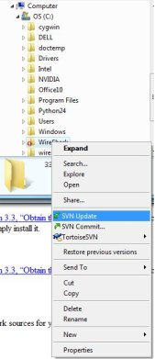

Figure 3.3 - TortoiseSVN

Step 6. Get the Latest Wireshark Source

The source tree contains the "plugins" directories that contain examples and a place to build your dissector.

1. Right-click on the C:\ drive in Windows Explorer.
2. In the upcoming context menu, select "SVN checkout.." andthenset:
3. The URL of the repository to http://anonsvn.wireshark.org/wireshark/trunk/.
4. The checkout directory to c:\wireshark.

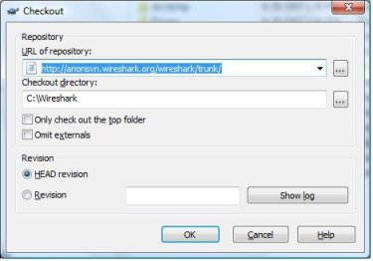

1. Select OK. You may be prompted to create the Wireshark directory. Select Yes.
2. TortoiseSVN starts downloading the source.
3. If the download fails, you may be behind a restrictive firewall. In this case, you better find an alternate way to get the source tree.

Step 7. Edit the config.nmake

Open C:\Wireshark\config.nmake using Notepad or your favorite text editor. Thefollowingsectionsmustbeupdated:

* **VERSION_EXTRA**: Give Wireshark your "private" version info. E.g.: -myprotocol123. Mine reads: SVN-AMINPROTOCOL. Youarewelcometoputwhateveryouwishhere.
* **PROGRAM_FILES**: Where your programs resides. Usually, just keep the default.
* **MSCV_VARIANT**: This part is critical. If your compiler isn't uncommented by default, you must **comment out** the current selection and **uncomment** your own. Forexample:

# "MicrosoftVisualStudio 6.0" - RECOMMENDED

# Visual C++ 6.0, _MSC_VER 1200, msvcrt.dll (version 6)

#MSVC_VARIANT=MSVC6

# "Microsoft Visual Studio .NET (2002)" - WORKS

# Visual C++ 7.0, _MSC_VER 1300, msvcr70.dll

#MSVC_VARIANT=MSVC2002

# "Microsoft .Net Framework SDK Version 1.0" - WORKS

# needs additional Platform SDK installation

# Visual C++ 7.0, _MSC_VER 1300, msvcr70.dll

#MSVC_VARIANT=DOTNET10

# "Microsoft Visual Studio .NET 2003" - WORKS

# Visual C++ 7.1, _MSC_VER 1310, msvcr71.dll

#MSVC_VARIANT=MSVC2003

# "Microsoft .Net Framework SDK Version 1.1" - WORKS

# needs additional Platform SDK installation

# Visual C++ 7.1, _MSC_VER 1310, msvcr71.dll

#MSVC_VARIANT=DOTNET11

# "Microsoft Visual Studio 2005" - WORKS

# Visual C++ 8.0, _MSC_VER 1400, msvcr80.dll

MSVC_VARIANT=MSVC2005 <------ This is my compiler. All others are commentedout.

# "Microsoft Visual C++ 2005 Express Edition" - WORKS

# needs additional Platform SDK installation

# Visual C++ 8.0, _MSC_VER 1400, msvcr80.dll

#MSVC_VARIANT=MSVC2005EE

# "Microsoft .Net Framework 2.0 SDK" - WORKS

# needs additional Platform SDK installation

# Visual C++ 8.0, _MSC_VER 1400, msvcr80.dll

#MSVC_VARIANT=DOTNET20

Step 8. Prepare cmd.exe

1. Start cmd.exe (Start > Run > "cmd")
2. Call "C:\Program Files\Microsoft Platform SDK for Windows Server 2003 R2\SetEnv.Cmd"
3. Call "C:\Program Files\Microsoft Visual Studio 8\VC\bin\vcvars32.bat"
4. cd c:\wireshark

Your paths may be slightly different depending on the compiler you use. In the example zip file, you will find a step1.bat, step2.bat, and a step3.bat. I made these batch files to simplify this step(see in the attachment).

Step 9. Verify Tools are Installed

From the C:\WireShark directory, execute:

C:\wireshark>Nmake –f Makefile.nmakeverify_tools

Your output should look like:

cl: /cygdrive/c/Programme/Microsoft Visual Studio 8/VC/BIN/cl

link: /cygdrive/c/Programme/Microsoft Visual Studio 8/VC/BIN/link

nmake: /cygdrive/c/Programme/Microsoft Visual Studio 8/VC/BIN/nmake

bash: /usr/bin/bash

bison: /usr/bin/bison

flex: /usr/bin/flex

env: /usr/bin/env

grep: /usr/bin/grep

/usr/bin/find: /usr/bin/find

perl: /usr/bin/perl

env: /usr/bin/env

C:/python24/python.exe: /cygdrive/c/python24/python.exe

sed: /usr/bin/sed

unzip: /usr/bin/unzip

wget: /usr/bin/wget

If something is missing, you may have to repeat the Cygwin install.

Step 10. Install Libraries

If you have closed your cmd.exe, you will have to reopen it and execute Step 8. You can use the step1, step2, step3batch files to simplify the process. From C:\Wireshark, execute:

nmake –f Makefile.nmake setup (This step may take a little while to complete.)

nmake –f Makefile.nmakedistclean

Step 11. Build Wireshark

If you have closed your cmd.exe, you will have to reopen it and execute Step 8. You can use the step1, step2, step3batch files to simplify the process.

nmake –f Makefile.nmake all (this step will take quite a while to complete)

You're done; provided the above steps worked!

Step 12. (Optional) Create a Wireshark Installer

I like the idea of distributing my version to friends. You can easily create an installer by doing the following:

1. Downloadandinstall NSIS.
2. Download vcredist_x86.exe and place it in the c:\wireshark-win32\libs directory. You may already have it in the directory, so check first.
3. Using the command line, prepare it using Step 8 or the Step1/2/3 batch files provided, and from C:\Wireshark, execute:

nmake –f Makefile.nmake packaging

1. You should now have a c:\wireshark\packaging\nsis\wireshark-setup<version />.exe. Try it out!</version />

## 3.2 Execute the Compiled Wireshark

To launch Wireshark, you simply can run C:\wireshark\wireshark-gtk2\wireshark.exe and check if it starts. I found that I needed to download and install Wireshark before my build worked. This is probably due to not having WinPcap installed prior.

Note: If you are using Visual Studio 2005, you will have to use your build of Wireshark to test the dissector. For some reason, compiling dissector plug-ins with Visual Studio 2005 prevents their use in the mainstream release of Wireshark. If you are using a different compiler, you may not have to use the compiled version of Wireshark.

### 3.2.1 Understanding the AMIN Protocol

Amin was nice enough to code up an excellent IOCP client/server example. His code uses a very simple protocol to transmit data via TCP.

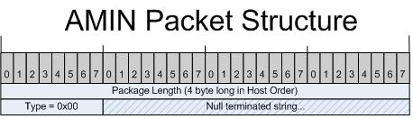

### 3.2.2 Package Length Prefix

All of Amin's packets are prefixed with a four (4) byte long value which indicates the size of the package. This value is presented in network order over the wire, or, MSB. Network order means that the bytes are ordered in such a way that the most significant bytes are first. For example, let's say your length is 12 decimal. This would be 0x0000000c in hex (if you are storing the value in a long). If you read this value off the "wire", it would appear as0c 00 00 00; this is "Network" order. You may be wondering why the bytes are reversed. If you think about it as an array of bytes, instead of a long, each byte is written in order. In this case, byte[0] is 0x0c, so it's written first. This is an important concept to understand.

When we use Wireshark to dissect the packet, it is important to understand that 2 and 4 byte integer values are always written in "Network" order, or LSB. In other protocols, the order may be Host – which would be LSB.

Note: The length accounts for the bytes to follow, meaning that the four (4) bytes which represent the length value are not included. For example, if you sent a packet that has 12 characters of text, the length would be 12+1 = 13 (the one byte is the type), as opposed to 12+1+4 = 17.

Amin follows the length prefix with a byte that indicates the "type" of the packet he is delivering. We will only be dealing with type 0x00, which is text. Note: a single byte is not subject to byte order because it's a single byte.

This field is simply a null terminated string which can be entered into Amin's MFC GUI. The default string is 'ABCDEFGHIJKLMNOPQRST123456789'.

## 3.3 Examining the AMIN protocol in Wireshark without a custom dissector

You can download the Simple IOCP Client/Server written by Amin. Here is what Wireshark looks like without a dissector for the AMIN protocol:

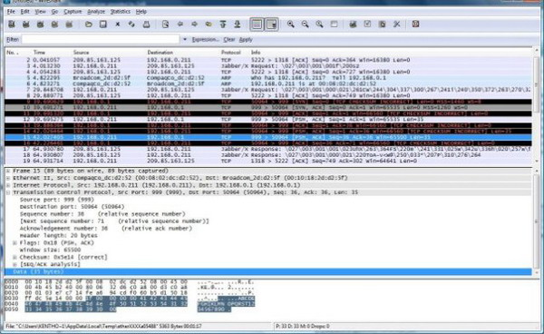

Notice that we are simply given a field called "Data". Within the data portion, we can recognize our AMIN protocol based on the "1f 00 00 00 00" package length. The type follows, and after that is the "ABC.." ASCII.

### 3.3.1 Writing Your Own Dissector

The Wireshark source tree contains a directory called Plugins, which provides a reasonable amount of examples. However, it was impossible to find a really "simple" example to use. So, in combination with the H223 dissector, random examples from the internet, and the developer guide/

In order to compile your own protocol, you must create a set of files to compile your dissector. The easiest thing to do is take the following files from the AMIN\ directory in the source zip file.

* Makefile.am - This is the UNIX/Linux makefile template
* Makefile.common - This contains the file names of this plug-in
* Makefile.nmake - This contains the Wireshark plug-in makefile for Windows
* moduleinfo.h - This contains the plug-in version info
* moduleinfo.nmake - This contains the DLL version info for Windows
* packet-amin.c - This is your dissector source
* plugin.rc.in - This contains the DLL resource template for Windows

Once you have copied the files into C:\Wireshark\plugins\yourprotocolname, you can begin editing them.

1. Change all occurrences of AMIN to your protocol name. Be sure to maintain capitalization. Lines: 42, 43, 114.
2. In Makefile.common, change all occurrences of AMIN to your protocol name. Besuretomaintaincapitalization. Line: 31.
3. In moduleinfo.h, change all occurrences of AMIN to your protocol name. Be sure to maintain capitalization. Line: 8. On line 16, you can change the version to your own. This can be helpful if you plan to distribute your dissector.
4. In moduleinfo.nmake, change all occurrences of AMIN to your protocol name. Be sure to maintain capitalization on Line 6. Lines 9, 10, 11, & 12 should be changed to reflect the version in moduleinfo.h, Line: 16.
5. In packet-amin.c, the first thing to do is change it so it reads packet-yourprotocol.c. All dissectors feature this convention, packet-protocolname.c. In the source file, you can simply do a "find and replace" for "amin". However, make sure that you replace the "AMIN" and "amin" references individually. In one case, you cannot submit the filter name in caps, and it will fail when you run Wireshark. Payverycloseattentionhere.
6. You're done renaming things for now; now, on to the actual code/

### 3.3.2 Your Dissector Code

You can use a text editor of your choice to open packet-yourprotocol.c. Let's take it line by line:

#ifdef HAVE_CONFIG_H

# include "config.h"

#endif

#include <span class="code-keyword"><stdio.h></span>

#include <span class="code-keyword"><glib.h></span>

#include <span class="code-keyword"><epan/packet.h></span>

#include <span class="code-keyword"><string.h></span>

All dissectors use some standard headers. You need the config.h, glib.h, and packet.h for sure.

#define PROTO_TAG_AMIN "AMIN"

I like to avoid hard coding constants when I can.

*/* Wireshark ID of the AMIN protocol */*

staticintproto_amin = -1;

This value is very important to Wireshark. Wireshark uses this to identify our protocol.

*/* These are the handles of our subdissectors */*

staticdissector_handle_tdata_handle=NULL;

staticdissector_handle_tamin_handle;

The dissector handle is what Wireshark uses to reference this dissector.

voiddissect_amin(tvbuff_t *tvb, packet_info *pinfo, proto_tree *tree);

This is a forward declaration of our dissection function. We will pass this function to a registration function later on.

staticintglobal_amin_port = 999;

This is the port that Wireshark will use to determine if the packet belongs to the AMIN protocol.

staticconstvalue_stringpackettypenames[] = {

{ 0, "TEXT" },

{ 1, "SOMETHING_ELSE" },

{ 0, NULL }

};

Here is where we add some optional text strings representing packet types. You can define many of these depending on the needs of your own protocol. It adds a level of detail that makes the dissector look well thought out.

staticginthf_amin = -1;

staticginthf_amin_header = -1;

staticginthf_amin_length = -1;

staticginthf_amin_type = -1;

staticginthf_amin_text = -1;

*/* These are the ids of the subtrees that we may be creating */*

staticgintett_amin = -1;

staticgintett_amin_header = -1;

staticgintett_amin_length = -1;

staticgintett_amin_type = -1;

staticgintett_amin_text = -1;

These allow us to attach IDs to the subcomponents of our protocol.

voidproto_reg_handoff_amin(void)

{

staticgboolean initialized=FALSE;

if (!initialized) {

data_handle = find_dissector("data");

amin_handle = create_dissector_handle(dissect_amin, proto_amin);

dissector_add("tcp.port", global_amin_port, amin_handle);

}

}

This function is called to register our protocol. Notice how the port and dissector handle are passed.

voidproto_register_amin (void)

{

*/* A header field is something you can search/filter on.*

*\**

*\* We create a structure to register our fields. It consists of an*

*\* array of hf_register_info structures, each of which are of the format*

*\* {&(field id), {name, abbrev, type, display, strings, bitmask, blurb, HFILL}}.*

*\*/*

statichf_register_infohf[] = {

{ &hf_amin,

{ "Data", "amin.data", FT_NONE, BASE_NONE, NULL, 0x0,

"AMIN PDU", HFILL }},

{ &hf_amin_header,

{ "Header", "amin.header", FT_NONE, BASE_NONE, NULL, 0x0,

"AMIN Header", HFILL }},

{ &hf_amin_length,

{ "Package Length", "amin.len", FT_UINT32, BASE_DEC, NULL, 0x0,

"Package Length", HFILL }},

{ &hf_amin_type,

{ "Type", "amin.type", FT_UINT8, BASE_DEC, VALS(packettypenames), 0x0,

"Package Type", HFILL }},

{ &hf_amin_text,

{ "Text", "amin.text", FT_STRING, BASE_NONE, NULL, 0x0,

"Text", HFILL }}

};

The array above defines what elements we will be displaying. These declarations are simply a definition Wireshark uses to determine the data type, when we later dissect the packet.

staticgint *ett[] = {

&ett_amin,

&ett_amin_header,

&ett_amin_length,

&ett_amin_type,

&ett_amin_text

};

The array above simply attaches IDs to our definitions. Notice the 1:1 relationship of the hf_ and ett_ data types.

proto_amin = proto_register_protocol ("AMIN Protocol", "AMIN", "amin");

proto_register_field_array (proto_amin, hf, array_length (hf));

proto_register_subtree_array (ett, array_length (ett));

register_dissector("amin", dissect_amin, proto_amin);

The above code registers our protocol. In most of the examples I saw, they check to see if proto_amin is initialized already. However, a developer from the mailing list, "Jaap", emailed me saying it was not needed and confused the initalization process. The subsequent calls register our protocol and data handles.

staticvoid

dissect_amin(tvbuff_t *tvb, packet_info *pinfo, proto_tree *tree)

{

The dissect function is used to actually dissect and display the packet details.

First, some points are initialized to trees/items:

proto_item *amin_item = NULL;

proto_item *amin_sub_item = NULL;

proto_tree *amin_tree = NULL;

proto_tree *amin_header_tree = NULL;

guint16 type = 0;

This next call checks to see if the INFO column is displaying our "AMIN" tag. If it's not, then we supply it.

if (check_col(pinfo->cinfo, COL_PROTOCOL))

col_set_str(pinfo->cinfo, COL_PROTOCOL, PROTO_TAG_AMIN);

*/* Clear out stuff in the info column */*

if(check_col(pinfo->cinfo,COL_INFO)){

col_clear(pinfo->cinfo,COL_INFO);

}

*//Here we check to see if the INFO column is present. If it is we output*

*//which ports the packet came from and went to. Also, we indicate the type*

*//of packet.*

*// This is not a good way of dissecting packets. The tvb length should*

*// be sanity checked so we aren't going past the actual size.*

type = tvb_get_uint8( tvb, 4 ); *// Get the type byte*

if (check_col(pinfo->cinfo, COL_INFO)) {

col_add_fstr(pinfo->cinfo, COL_INFO, "%d > %d Info Type:[%s]",

pinfo->srcport, pinfo->destport,

val_to_str(type, packettypenames, "Unknown Type:0x%02x"));

}

If there is a "tree" requested, we handle that request.

if (tree) { */* we are being asked for details */*

guint32 offset = 0;

guint32 length = 0;

This call adds our tree to the main dissection tree.

amin_item = proto_tree_add_item(tree, proto_amin, tvb, 0, -1, FALSE);

amin_tree = proto_item_add_subtree(amin_item, ett_amin);

amin_header_tree = proto_item_add_subtree(amin_item, ett_amin);

amin_sub_item = proto_tree_add_item(amin_tree, hf_amin_header,

tvb, offset, -1, FALSE );

Here, we add our own subtree, so we can have a "header" collapsible branch. Following the subtree, we copy out the length bytes to our data type. The order of the long value representing length is "network" order. If someone has a more appropriate tvb_get call to read the length value, it would be appreciated.

amin_header_tree = proto_item_add_subtree(amin_sub_item, ett_amin);

*//We use tvb_memcpy to get our length value out (Host order)*

tvb_memcpy(tvb, (guint8 *)&length, offset, 4);

proto_tree_add_uint(amin_header_tree, hf_amin_length, tvb, offset, 4, length);

*//We increment the offset to get past the 4 bytes indicating length*

offset+=4;

*//Here we submit the type parameter to the tree.*

proto_tree_add_item(amin_header_tree, hf_amin_type, tvb, offset, 1, FALSE);

type = tvb_get_guint8( tvb, offset ); *// Get our type byte*

offset+=1;

*//If the type is TEXT, we add the text to the tree.*

if( type == 0 )

{

proto_tree_add_item(amin_tree, hf_amin_text, tvb, offset, length-1, FALSE );

}

### 3.3.3 Compiling packet-yourprotocol.c

If your command line window is still open, you can use that, or use step1/2/3.bat to arrive at the c:\wireshark\plugins\yourprotocol directory. If you are building my source code, you should be at c:\wireshark\plugins\amin. From the "prepared" command line, see Step 8. Execute:

nmake -f Makefile.nmakedistclean

nmake -f Makefile.nmake all

If the build succeeds, you should have a yourprotocol.dll. Simply copy this file to your C:\WireShark\wireshark-gtk2\plugins\0.99.7-YOUR-BUILD directory. There should be a bunch of other dissector DLLs present there. You may need to copy it to your c:\program files\wireshark\plugins\0.99.7-YOUR-BUILD directory if you installed it there. The bottom line is to copy it in the appropriate directory based on how you are launching Wireshark. At this point, you should be able to launch Wireshark and dissect packets. A good test is to enter "yourprotocol" in the "filter" area of Wireshark and see if a green or red background forms. A green background, just like in the screenshots of this article, indicates that the dissector loaded correctly.



This is a screen capture of the AMIN protocol being dissected by Wireshark.

## 3.4CodeBaseandOther Examples:develop Wireshark dissectors using the TSN.1

I found an immense amount of examples in a searchable form at CodeBase. Without this site, it would have been a much more difficult task locating functions for dissection. Someone really should spend time documenting the Wireshark API in a more formal manner.

A coworker informed me that CodeBase is a pay service. I was able to get into CodeBase beta without having to authenticate. Use this link to do the same (use the search box to find undocumented methods).

After you've defined your data type map, you can use the '.' operator to limit the packets being displayed. For example, amin.type==0 will only show packets where the type equals zero.

There are far more complex examples that can be found in the plugins directory. My suggestion is to check out the H223 dissector. Topics such as TCP segmentation are covered, as well as managing states across combinations of packets (i.e., watching a SIP session throughout multiple packets).

thispart, we will show you a fast and easy way to develop Wireshark dissectors using the TSN.1 Compiler. We will give you step-by-step instructions on how to develop a custom dissector plugin.

Step 1. Download and Build the Wireshark Source Code

You must build Wireshark from source code before you can build any custom dissector. If you already have a working build, you can skip this step and go to step 2. This tutorial uses a Linux build environment. For Windows build instructions, please refer to the official Wireshark documentation. First download the Wireshark source code package from wireshark.org. Then issue the following command at the prompt:

> tar xvjf wireshark-2.2.6.tar.bz2

>cd wireshark-2.2.6

> ./configure

> make

If you don't have all the packages required by Wireshark installed on your system, the "configure" command will fail. Install the missing packages and try "configure" again followed by "make". It takes a few minutes for the build to complete. You can verify the build is successful by typing "./wireshark" at the prompt, and the Wireshark main GUI should pop up.

Step 2. Download the Dissector Code for the Echo Protocol

For this part we will develop a dissector for a simple protocol called "Echo". Save the downloaded file "echo_dissector.tar.gz" under the "wireshark-2.2.6" directory and untar it.

> tar zxvf echo_dissector.tar.gz

This will install the echo dissector code under "plugins/echo". Most of the files are boilerplate. They are required for all dissectors. The only two files you need to pay attention to are "packet-echo.c" and "echo.tsn".

The "packet-echo.c" implements functions that are required for every dissector to register itself with Wireshark. For example, the dissector tells Wireshark the type of packet and the port it wants to dissect. In our example, we want to dissect UDP packets on port 3001.

#define ECHO_PORT 3001

voidproto_reg_handoff_echo(void)

{

staticdissector_handle_techo_handle;

echo_handle = create_dissector_handle(dissect_echo, proto_echo);

**dissector_add_uint("udp.port", ECHO_PORT, echo_handle);**

}

To dissect any packet, the dissector must register its data fields with Wireshark so that Wireshark knows how to display them. This is done by the "proto_register_echo" function. The real work is actually done inside the "EchoPacket_register" function. Writing this function by hand is quite tedious and boring. Fortunately as we will show later, this can be auto-generated.

voidproto_register_echo(void)

{

/* Setup protocol subtree array */

staticint *ett[] = { &ett_echo };

/* We use the name "echo2" here because there is already a built-in

protocol called "echo". */

proto_echo = proto_register_protocol

(

"Echo Protocol", /* name */

"ECHO2", /* short name */

"echo2" /* abbrev */

);

/* call the TSN.1 Compiler generated register function */

**EchoPacket_register(proto_echo);**

proto_register_subtree_array(ett, array_length(ett));

}

Finally, the code to dissect packets is implemented in the "dissect_echo" function. Wireshark will call this function for every UDP packet received on port 3001. Again the real work is done in the "EchoPacket_dissect" function. Both "EchoPacket_register" and "EchoPacket_dissect" are defined in "echo.c" with their prototypes declared in "echo.h". You will notice that "echo.h" and "echo.c" are not in the "plugins/echo" directory. In the next step, we will show you how to auto-generate them from "echo.tsn".

static void dissect_echo(tvbuff_t *tvb, packet_info *pinfo, proto_tree *tree)

{

if (check_col(pinfo->cinfo, COL_PROTOCOL))

col_set_str(pinfo->cinfo, COL_PROTOCOL, "ECHO");

/* Clear out stuff in the info column */

if (check_col(pinfo->cinfo,COL_INFO)) {

col_clear(pinfo->cinfo,COL_INFO);

}

if (tree) { /* we are being asked for details */

proto_item *ti;

EchoPacket *msg;

ti = proto_tree_add_item(tree, proto_echo, tvb, 0, -1, FALSE);

tree = proto_item_add_subtree(ti, ett_echo);

msg = (EchoPacket *) ep_alloc(sizeof(EchoPacket));

/* call the TSN.1 Compiler generated dissect function */

**EchoPacket_dissect(msg, proto_echo, tvb, 0, pinfo, tree);**

}

}

Step 3. Generate the Custom Dissector Code using the TSN.1 Compiler

The "echo.tsn" file describes the echo protocol message formats in a formal notation called TSN.1. TSN.1 is a simple yet powerful notation for describing binary protocols. Please refer to the TSN.1 Specification for description and examples of TSN.1. Below is the source listing for "echo.tsn".

EchoMsgType ::= **enumerated**

{

ECHO_REQUEST,

ECHO_RESPONSE

}

EchoReq() ::=

{

SequenceNumber 8;

}

EchoRsp() ::=

{

SequenceNumber 8;

}

EchoPacket() ::=

{

// Header Fields

Type 8 **enumerated**EchoMsgType;

SrcAddress 32; <display>ipv4</display>

DstAddress 32; <display>ipv4</display>

// Message Specific Fields

Payload :**case** Type **of**

{

ECHO_REQUEST =>echoReq : EchoReq;

ECHO_RESPONSE =>echoRsp :EchoRsp;

}

}

There are two messages in the echo protocol, "EchoRequest" and "EchoResponse". The format of an echo packet is described by the "EchoPacket" message. Each packet starts with some common header fields. The 8-bit "Type" field indicates the type of the payload the message carries, whether it is an "EchoReq" message or an "EchoRsp" message. The 32-bit "SrcAddress" and "DstAddress" fields specify the IPv4 addresses of the sender and the receiver respectively. After the header fields comes the message payload, which is defined using the TSN.1 **case of** construct. If the "Type" is equal to the enumerated constant "ECHO_REQUEST" (0), then the payload contains an "EchoReq" message. If the "Type" is "ECHO_RESPONSE" (1), then the payload contains an "EchoRsp" message.

To generate the dissector code from "echo.tsn", first download the TSN.1 Compiler  and follow the installation guide to install it. Assuming you have installed the TSN.1 Compiler under your home directory, type the following command to generate "echo.h" and "echo.c" from "echo.tsn":

>cd plugins/echo

> ~/tsnc-v5.8.3/bin/tsnc -wiresharkecho.tsn

You should find "echo.h" and "echo.c" in the "plugins/echo" directory.

Step 4. Build the Dissector Plugin

Now we have the dissector code generated. Let's rebuild Wireshark with the new echo dissector plugin. Change the current directory back to "wireshark-2.2.6".

>cd ../..

> ./autogen.sh

> make -C plugins

The "autogen.sh" script should be invoked every time a new dissector plugin is added to the Wireshark build tree. The "make -C plugins" command is used to build the echo dissector plugin every time you make change to the dissector code.

Step 5. Dissect Packets

Now we are ready to dissect packets of the echo protocol using Wireshark. To illustrate how this works, we will use data from a pre-captured data file: plugins/echo/echo_data.

Launch Wireshark and go to the "File" menu and select "Open", locate the "echo_data" file and open it. You will see that there are two packets: one containing an "EchoReq" message and the other, an "EchoRsp" message. Click on a packet to browse the detailed dissect output for the packet. See the screenshot below:

[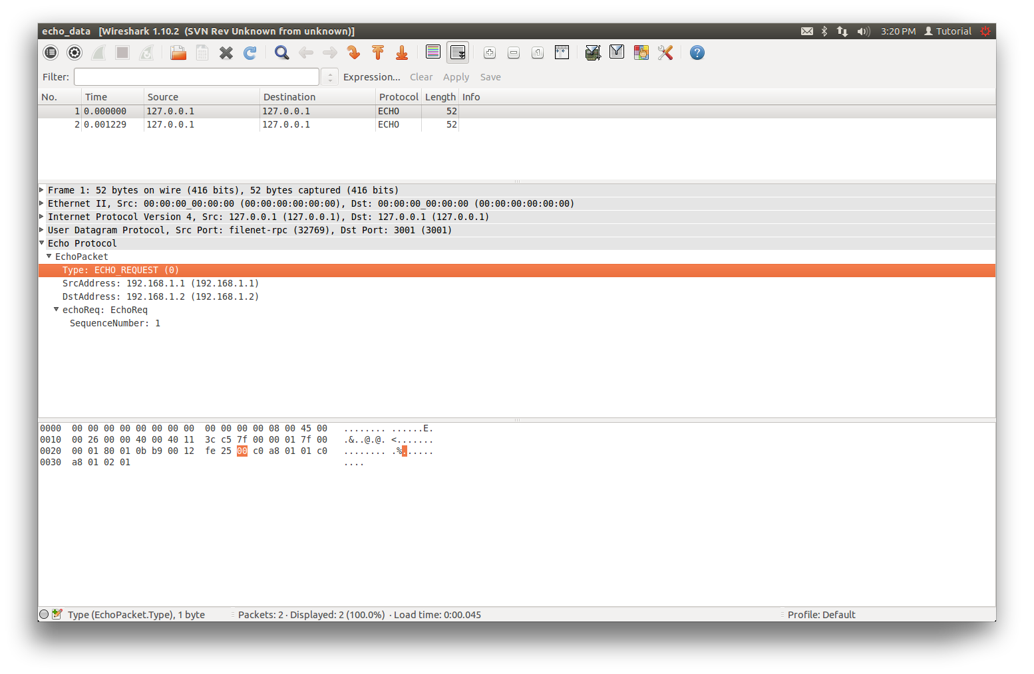](http://www.protomatics.com/images/echo_dissector.png)